1. Task based

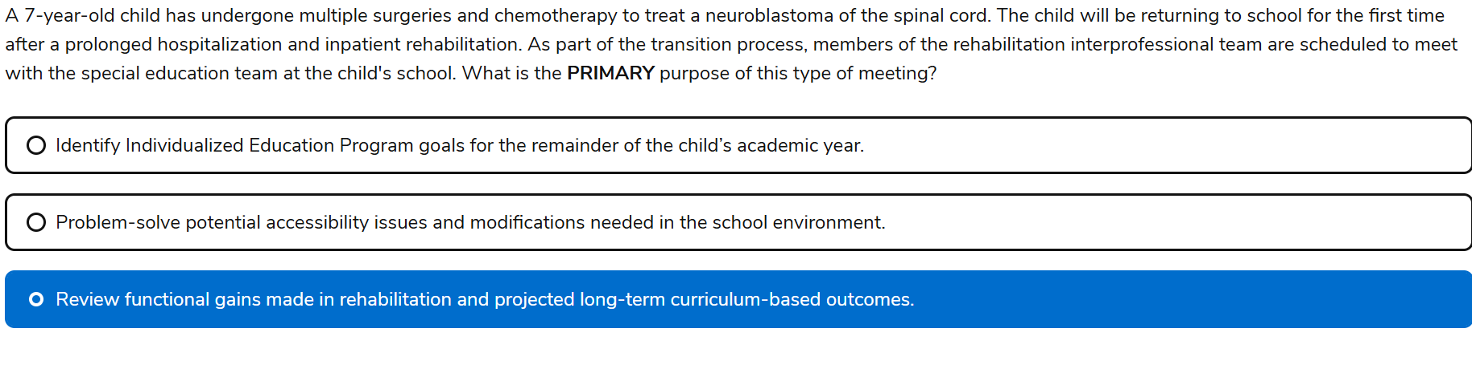

1. Task based?

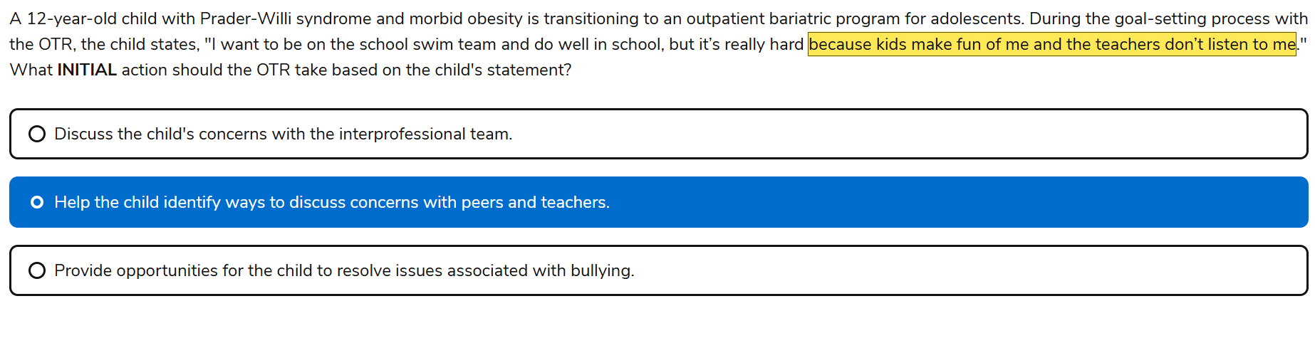

1. 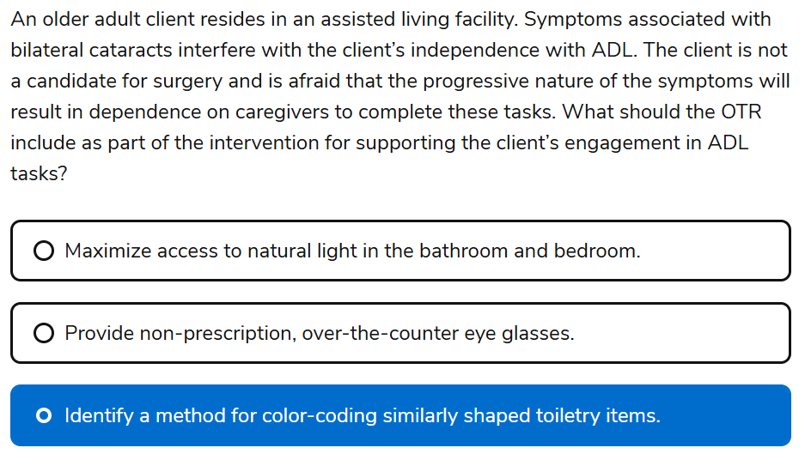
2. Task COPD diaphragmatic breathing, acute dyspnea use pursed lip breathing sitting bending forward to to rest head.
   1. Assessment for COPD is American Thoracic Society Respiratory Questionnaire and Grade of Breathlessness Scale

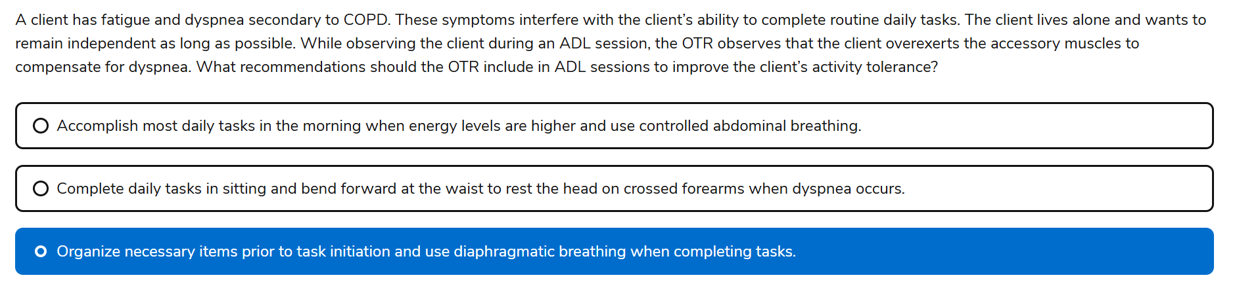

Pedrett’s book

Intervention Techniques

**Dyspnea control postures.** Adopting certain postures can reduce breathlessness. In a seated position, the patient bends forward slightly at the waist while supporting the upper part of the body by leaning the forearms on a table or the thighs. In a standing position, relief may be obtained by leaning forward and propping oneself on a counter or shopping cart.

**Pursed-lip breathing.** Pursed-lip breathing (PLB) is thought to prevent tightness in the airway by providing resistance to expiration. PLB improves air movement, releasing trapped air in the lungs and helps to keep the airways open. Persons with COPD sometimes instinctively adopt this technique, whereas others may need to be taught it. Instructions for PLB are as follows: 1. Relax your neck and shoulder muscles. 2. Inhale slowly through the nose for a count of two. 3. Purse the lips as if to whistle. 4. Exhale—slowly, to a count of 4—through pursed lips as if trying to make a candle flicker without blowing it out. Pursed lip breathing should be used when bending, lifting, or stair climbing.

**Correct Diaphragmatic breathing**. Another breathing pattern, which calls for increased use of the diaphragm to improve chest volume, is diaphragmatic breathing. Many persons learn this technique by placing a small paperback novel on the abdomen just below the xiphoid process (base of the sternum or breastbone). The novel provides a visual cue for diaphragmatic movement. The patient lies supine and is instructed to inhale slowly and make the book rise. Exhalation through pursed lips should cause the book to fall.

1. INCORRECT Knowledge based- Transhumeral amputation
   1. Pedretti’s book says that hybrid prostheses (body powered and electrically powered) is commonly used.

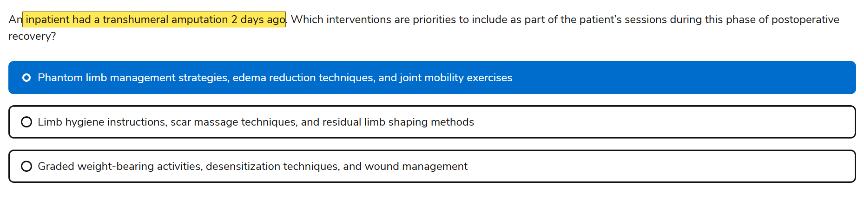

1. Knowledge beased. Patients return home for safety of ADLS and IADLS.
   1. **Kohlmans Evaluation of living skills Living** (skills evaluation that includes ratings of 17 tasks (e.g., safety awareness, money management, phone book use, money and bill management) ->ADLs and IADLs
   2. **Barthel Index:** Measure of disability in performing BADLs that ranges from 0 to 20 or 0 to 100 (by multiplying each item by 5); includes 10 items: bowels, bladder, feeding, grooming, dressing, transfer, toileting, mobility, stairs, and bathing
   3. **Kitchen Task Assessment (KTA):** determines the level of cognitive support a person with AD needs to complete a cooking task successfully
2. task

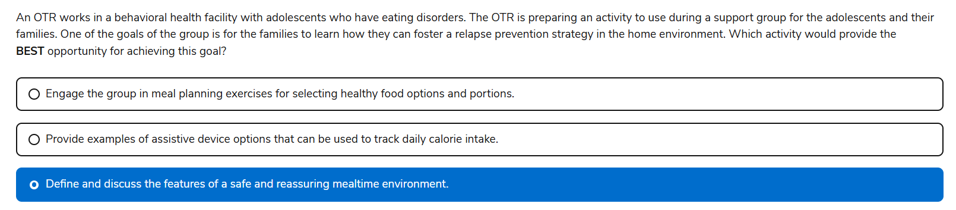

1. Task based

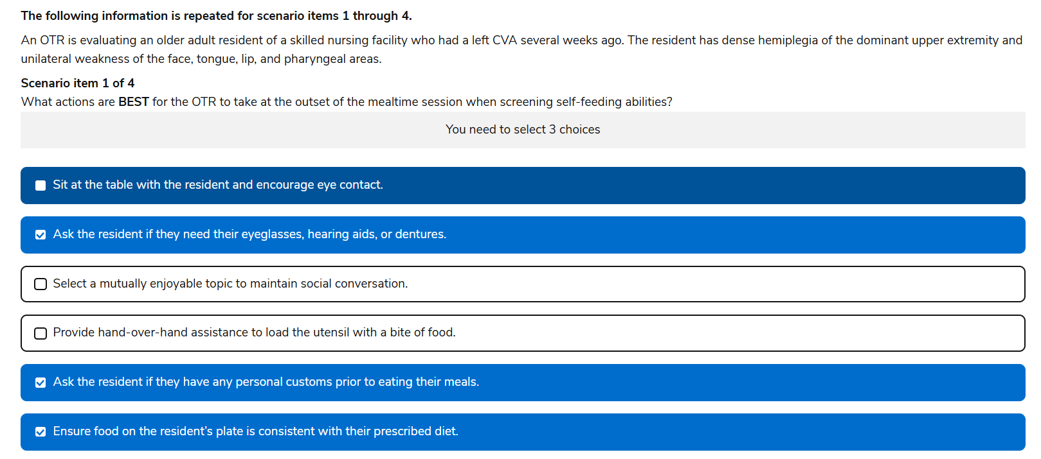

1. incorrect
2. Task based
3. Task based
4. Task based

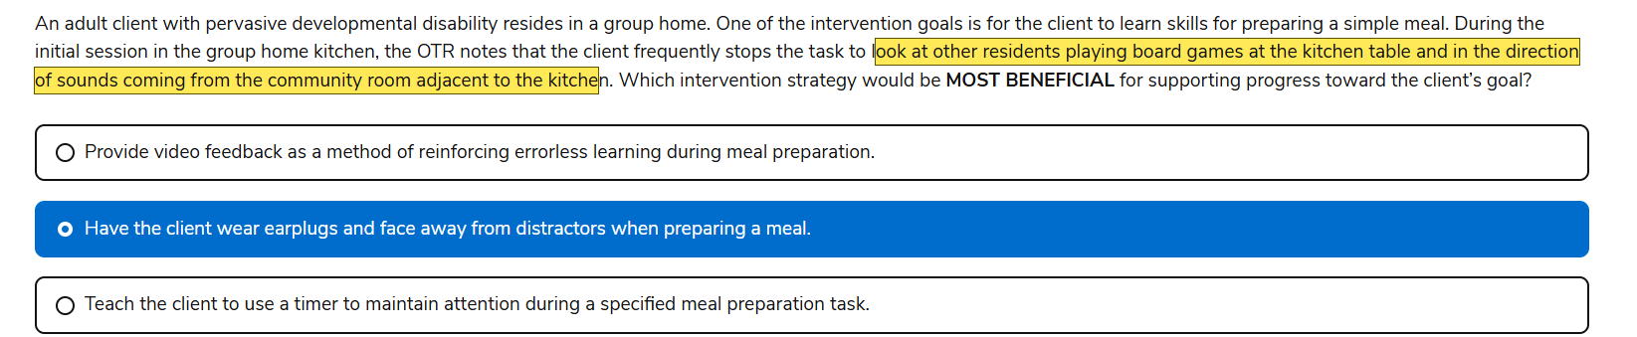

1. Mixed

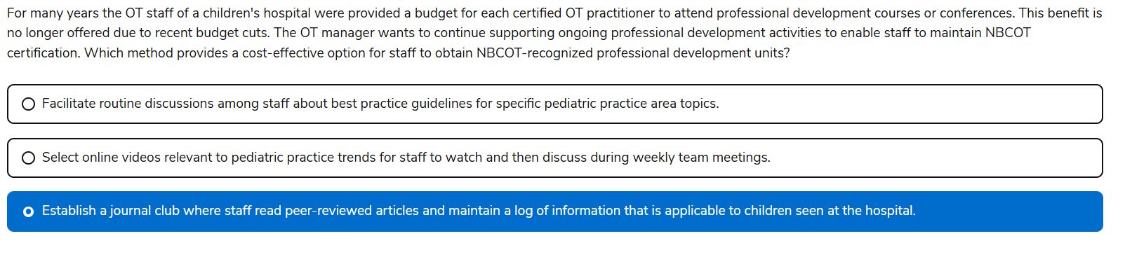

14 Task

Look at public transportation

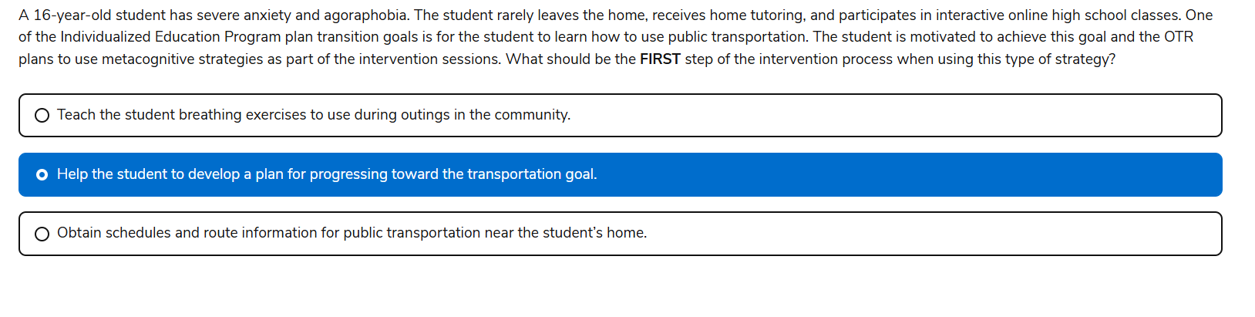

15

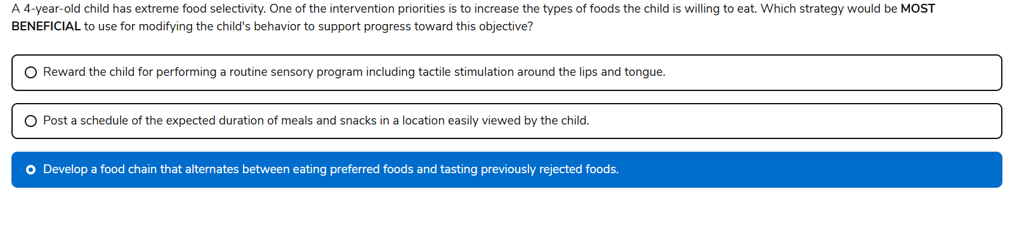

16

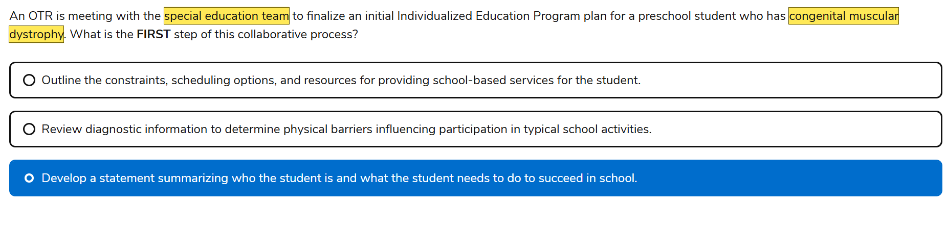

17 task

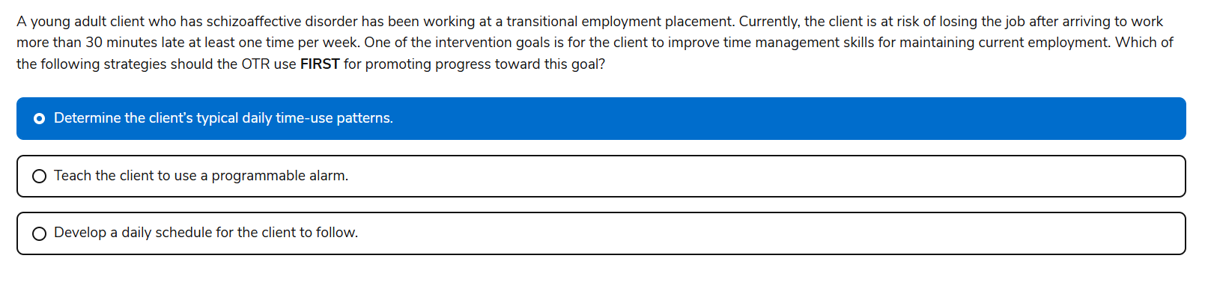

18

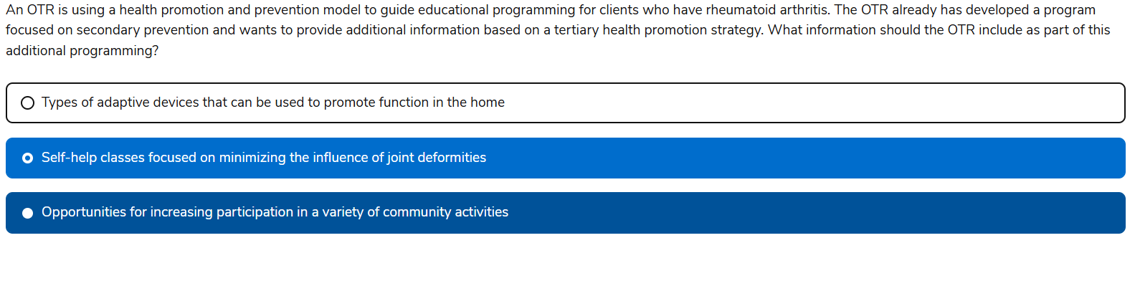

19

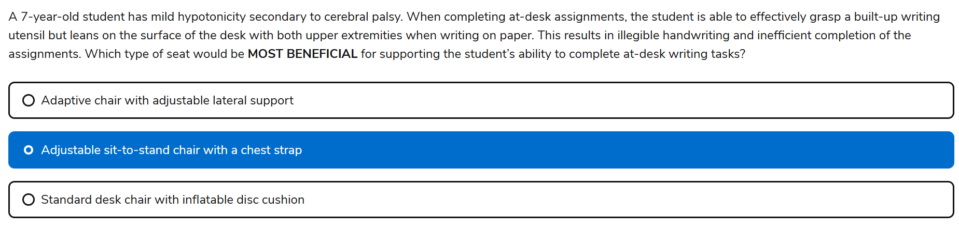

20

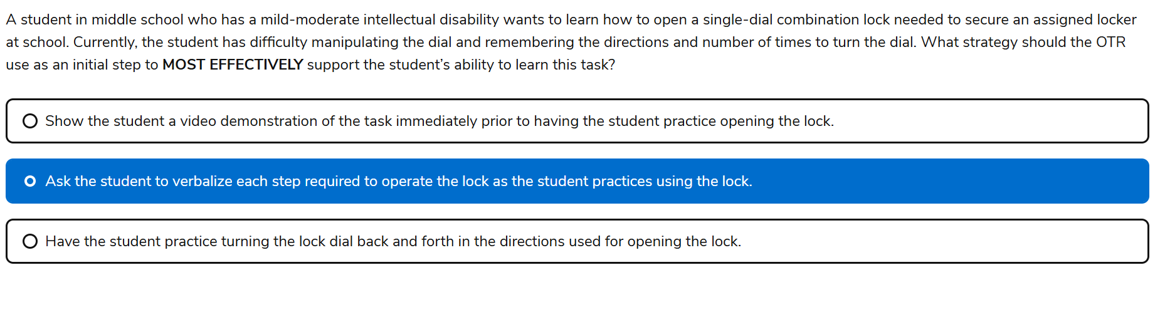

1. RA ; Community participation is PRIMARY( encourages general wellness, not condition specific management). TYPES of adaptive devices would be SECONDARY focusing on early functional support, not long term deformity management. Tertiary is self help classes for minimizing influence of joint deformity and managing chronic conditions

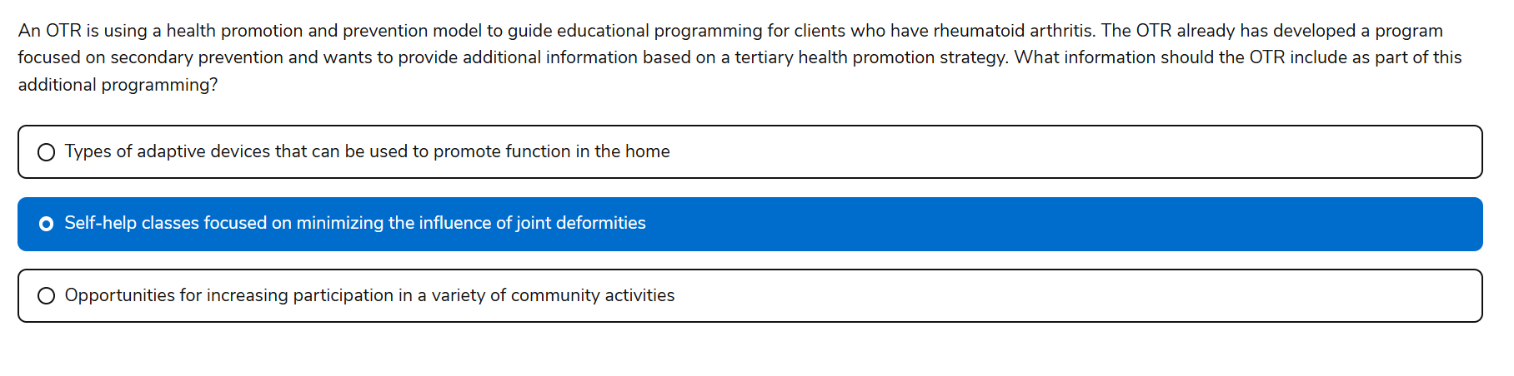

1. CP Hypotonia

🧠 Rationale:

* The child leans on the desk with both arms—suggesting **poor trunk stability**.
* Lateral supports help maintain **upright posture**, freeing the arms for functional use.
* This improves **handwriting legibility** and **task efficiency**.

❌ B) Adjustable sit-to-stand chair with a chest strap

* This type of chair is typically used for **postural control and standing tolerance**, not for seated fine motor tasks.
* A **chest strap** may be overly restrictive for a child with **mild hypotonicity**, especially if they can grasp and sit independently.
* It doesn’t directly address the **need for proximal stability** during seated writing.

❌ Why C Is Less Appropriate:

* An **inflatable disc cushion** promotes dynamic sitting, which can be helpful for attention or core activation.
* But for this child, it may **exacerbate instability**, not improve it

21. Dysphagia Diet Level 2

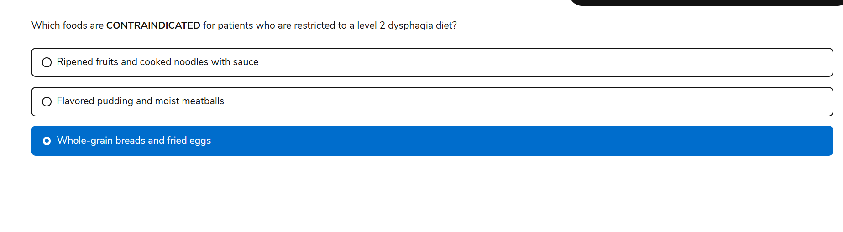

🧠 Correct Answer:

**“Whole-grain breads and fried eggs”**

🔍 Why This Is Contraindicated for Level 2 Dysphagia Diet:

A **Level 2 (mechanically altered)** dysphagia diet includes:

* Moist, soft-textured foods
* Foods that require **some chewing**, but are easy to swallow

**Whole-grain breads**:

* Often **dry, coarse, and crumbly**
* Can pose a **choking risk** or leave residue in the throat

**Fried eggs**:

* Have **variable textures** (crispy edges, rubbery whites)
* May be **difficult to chew and swallow safely**

✅ Safer Alternatives:

* **Moist meatballs**: Soft and cohesive
* **Flavored pudding**: Smooth and easy to swallow
* **Cooked noodles with sauce**: Soft and slippery

22. Task based- IEP

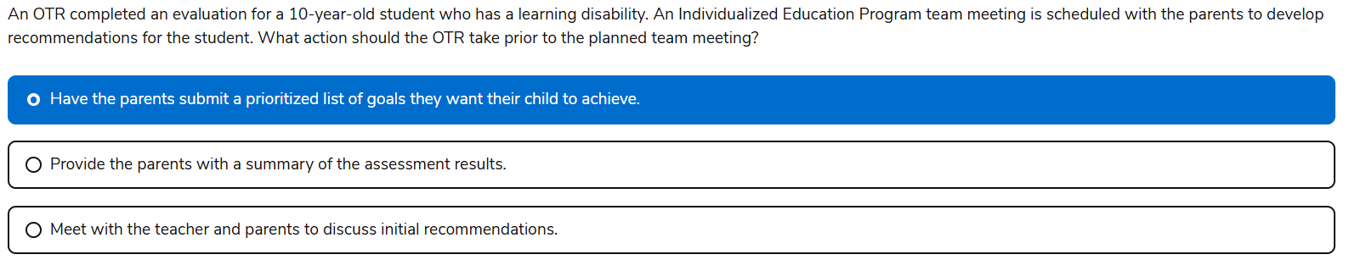

23. Knowledge- Spinal cord injury C5

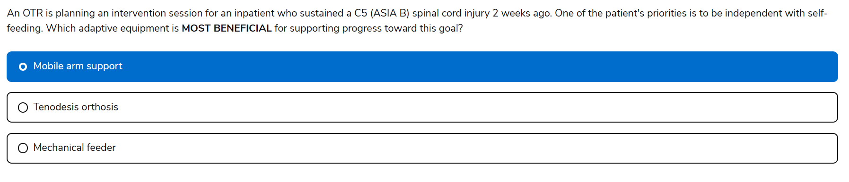

24. Task based

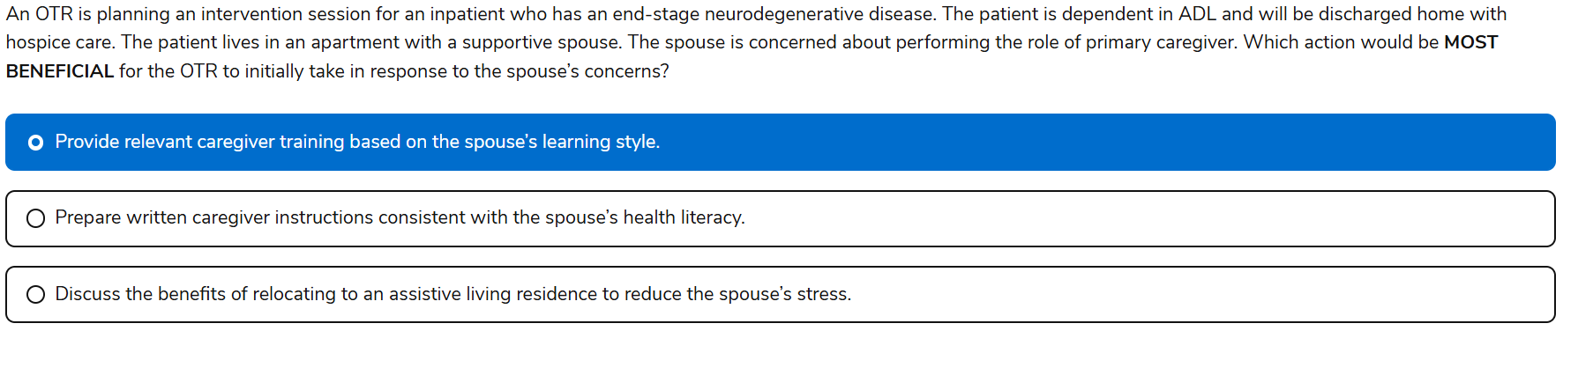

25. Task based

-Problem is child wont go to school, i thought initially the child need help resolving dysfunctional emotions which is A

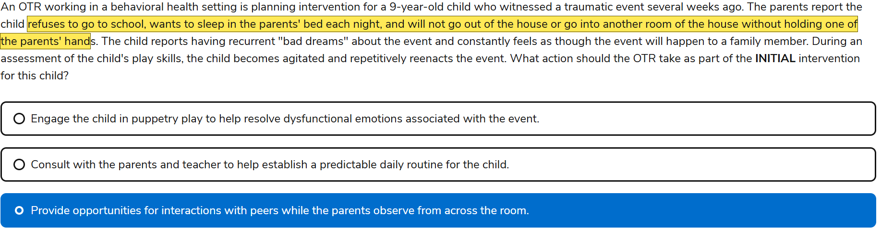

26. Task based, word prediction

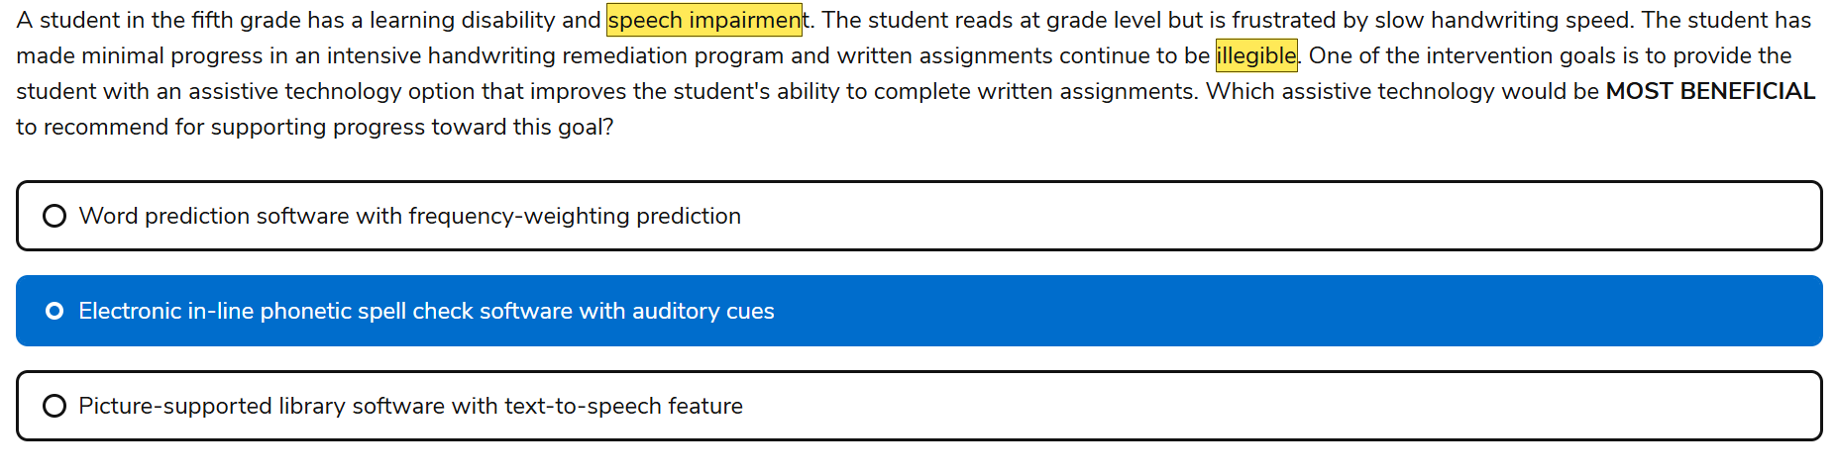

27. Task-

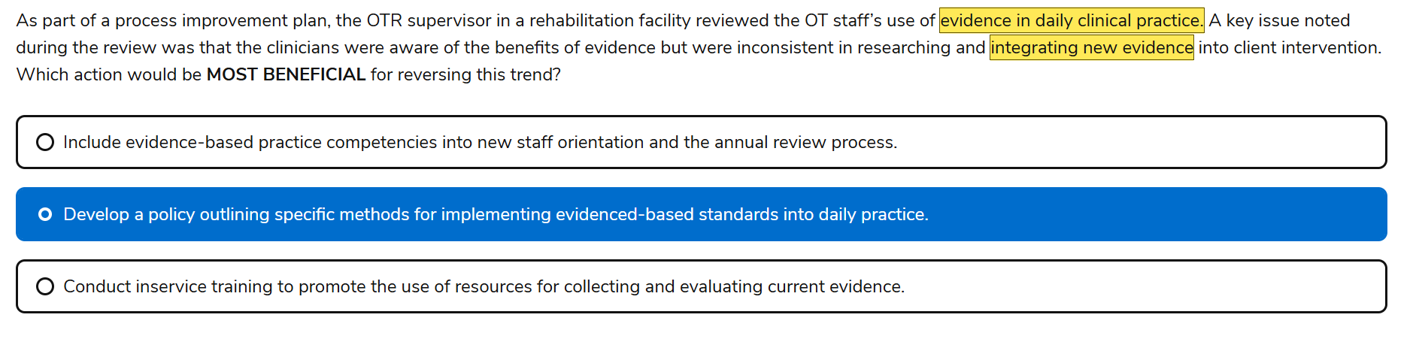

28. Mix

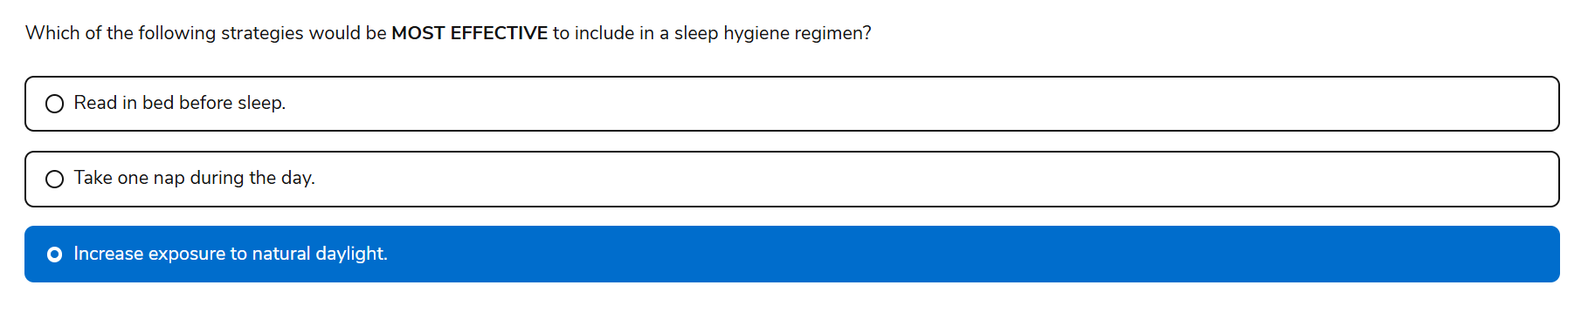

29. Task based

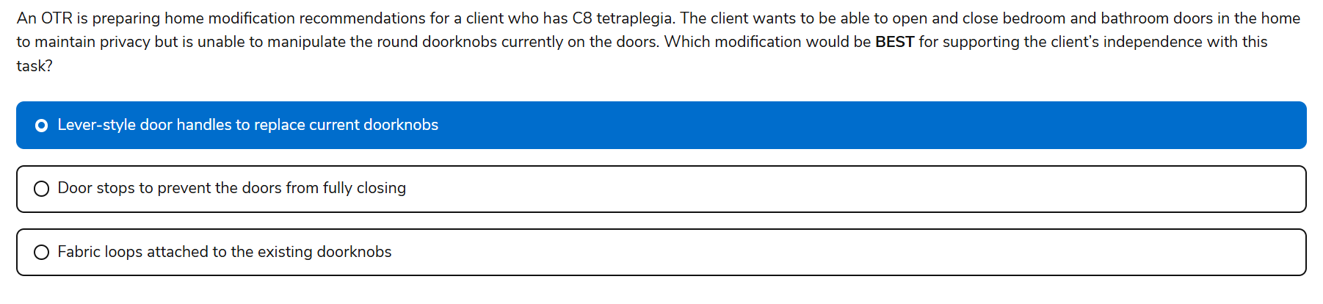

30. Knowledge, wheelchairs

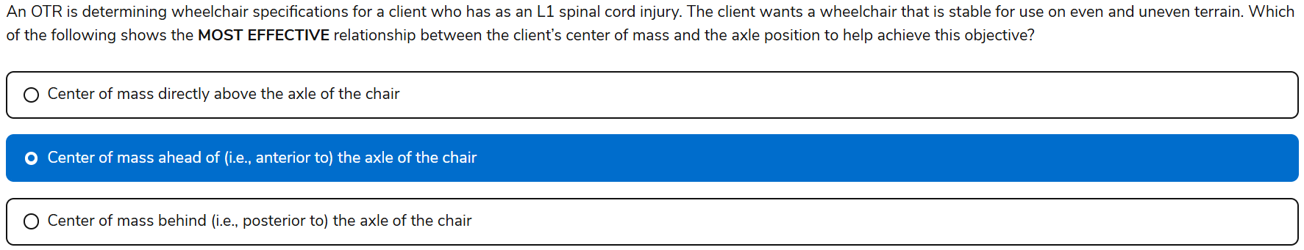

Yes, Keely—your selected answer, **“Center of mass ahead of (i.e., anterior to) the axle of the chair,”** is **correct** for this scenario. 🎯

Let’s walk through the clinical reasoning:

🧠 Context:

* Client has an **L1 spinal cord injury**, meaning:
* **Full upper extremity function**
* **Some trunk control**, but not full
* Likely uses a **manual wheelchair** for mobility

✅ Why “Center of mass anterior to the axle” is best:

* Shifting the center of mass **slightly forward** improves **stability**, especially on **uneven terrain**
* Reduces the risk of **tipping backward**
* Ideal for clients who need **more control and safety** during outdoor or community mobility

❌ Why the other options fall short:

* **Directly above the axle**:
  + Offers **optimal maneuverability**, but **less stability**
  + Better for experienced users who prioritize speed and agility
* **Posterior to the axle**:
* Increases risk of **rear tipping**, especially on inclines or rough surfaces
* Not recommended for someone who needs **stability first**

This question taps into your understanding of **biomechanics**, **wheelchair configuration**, and **functional mobility**—all high-yield NBCOT content.

Want me to help you build a printable wheelchair setup guide by SCI level and terrain type? It could be a killer reference for both exam prep and clinical practice.

31. Mix, MS severe tilt in space

A wedge cushion is used for short term pressure relief

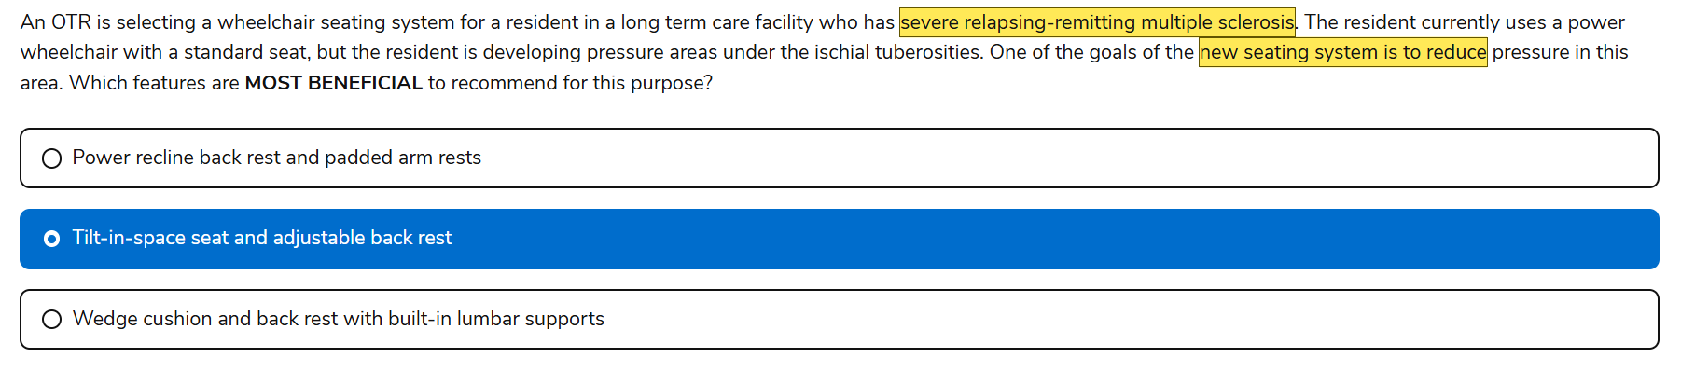

32. Knowledge, the COSA is apart of the MOHO (what matters to them and competent they feel

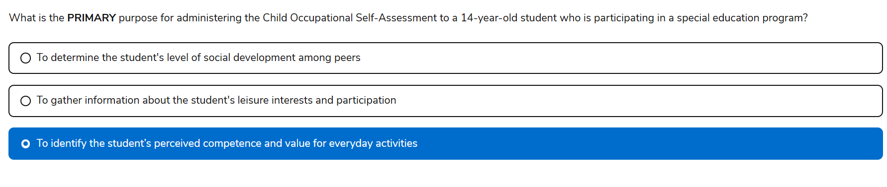

33. Task based

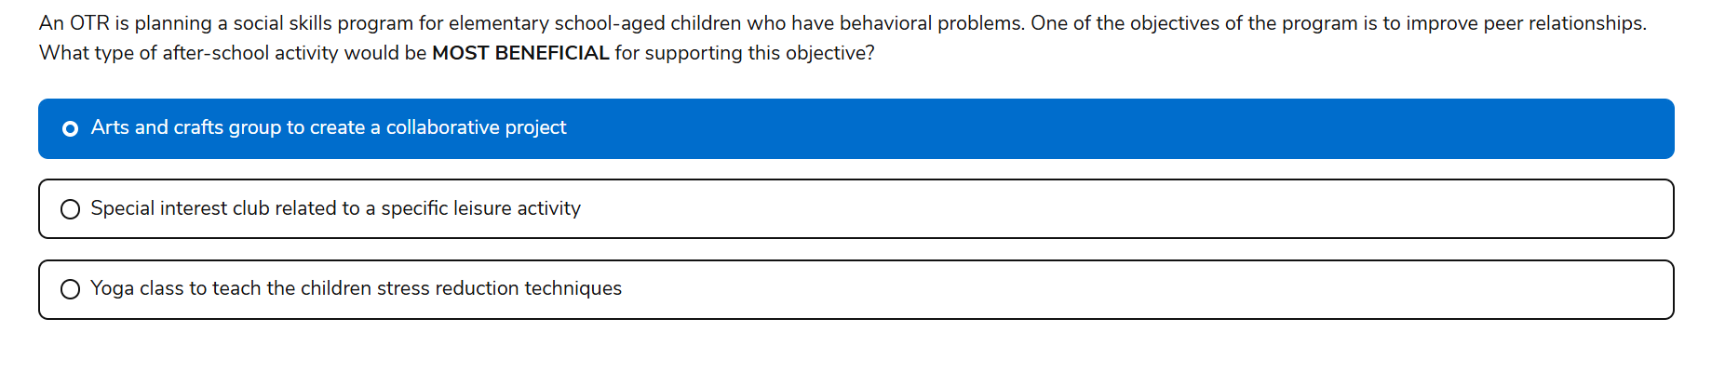

34. mixed , wheelchair ADA

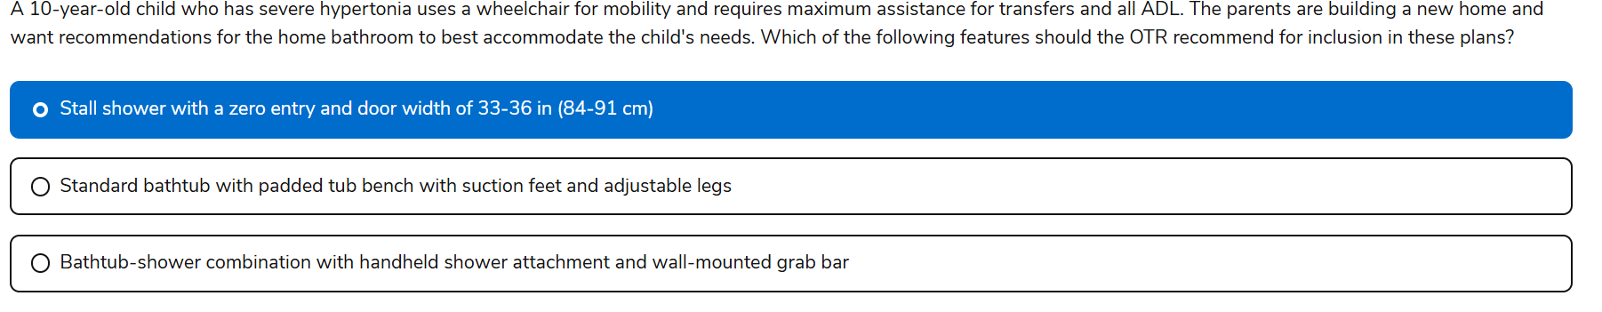

35. Knowledge

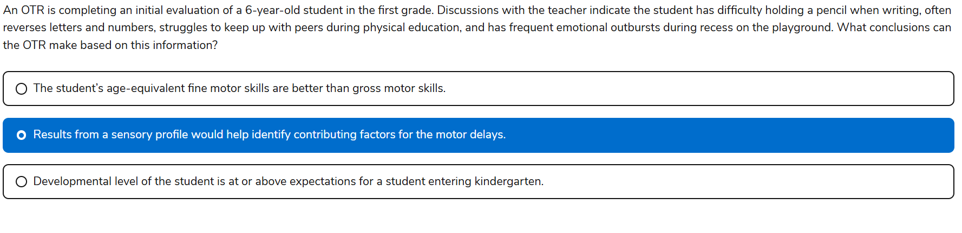

36. Knowledge

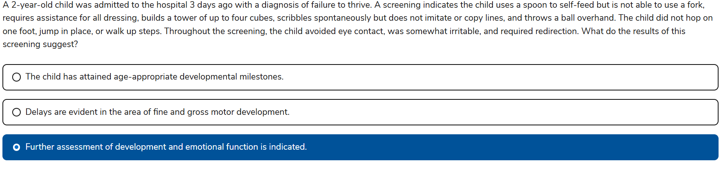This question is a classic example of how NBCOT tests your ability to interpret data, advocate for the client, and initiate appropriate next steps. Want help building a printable flowchart for pediatric developmental screening and referral decisions? It could be a great visual anchor for your prep.

37. Task based

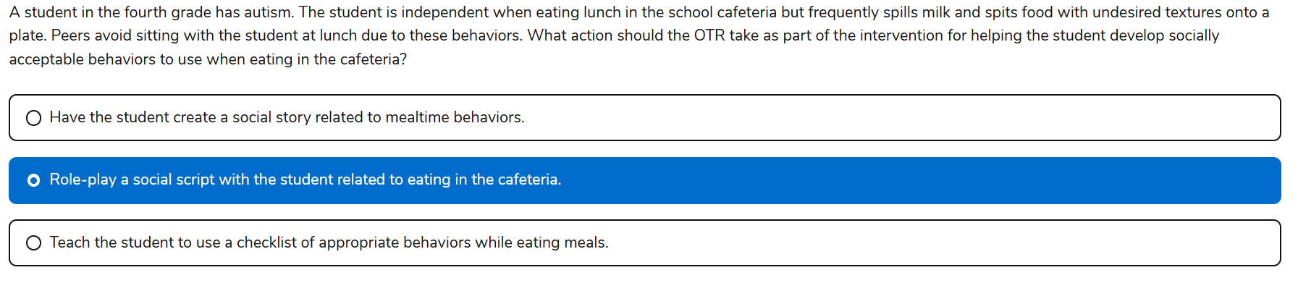

38. Mix

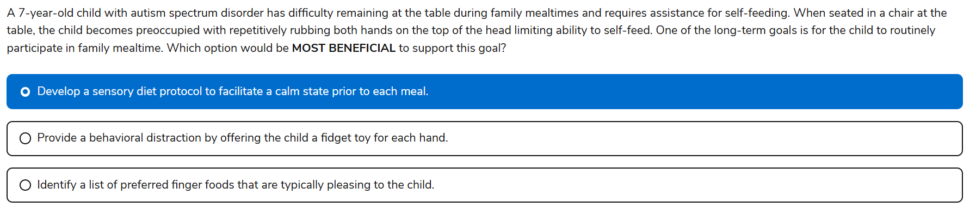 Why the Sensory Diet Protocol Is the Best Choice

* The child’s **repetitive hand-rubbing behavior** suggests **sensory-seeking or dysregulation** that interferes with self-feeding
* A **sensory diet** is a **preventive, individualized plan** that helps regulate arousal levels before challenging tasks
* By facilitating a **calm, organized state prior to mealtime**, the child is more likely to remain seated and engage in feeding
* This approach supports **routine participation**, not just isolated behavior management

39. Task based

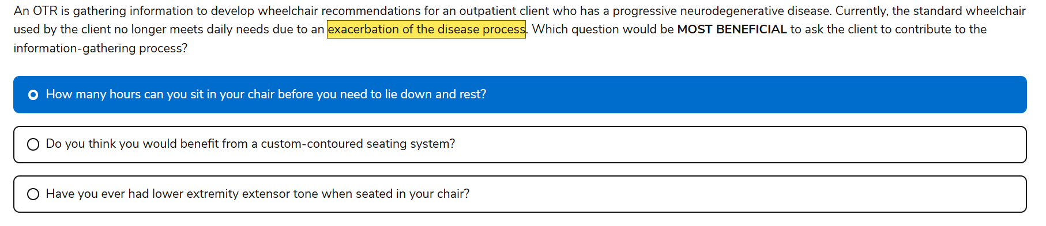

40. Knowledge RLA

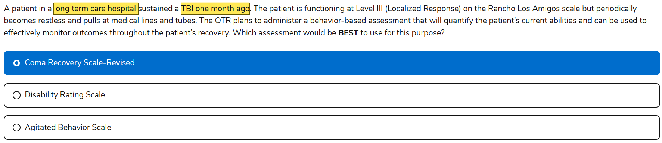

**IMPORTANT Ranchos los Amigos scale assessments**

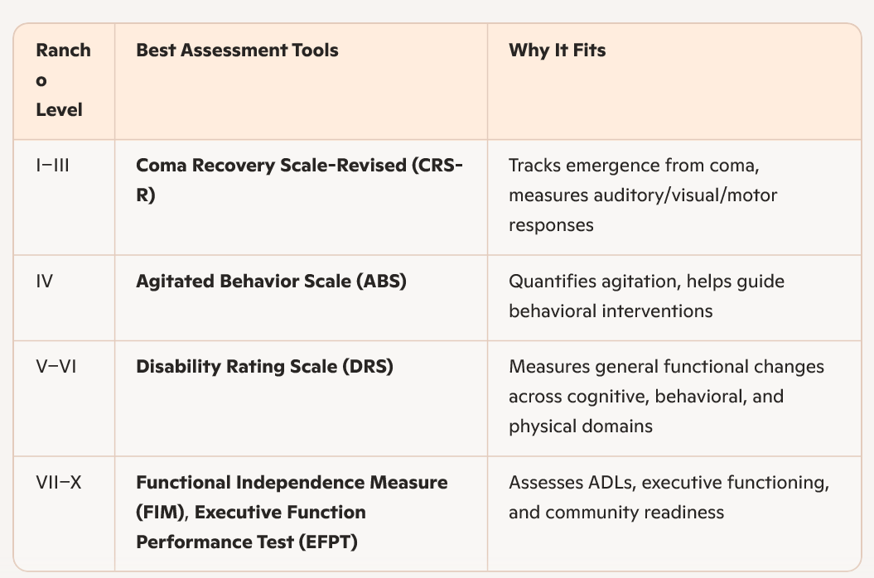

41. Task based, C4

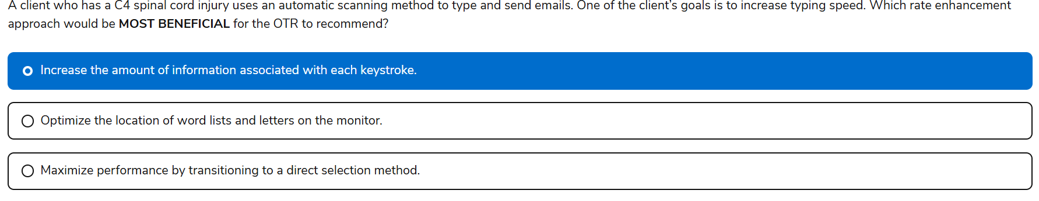

42. Sling for shoulder subluxation

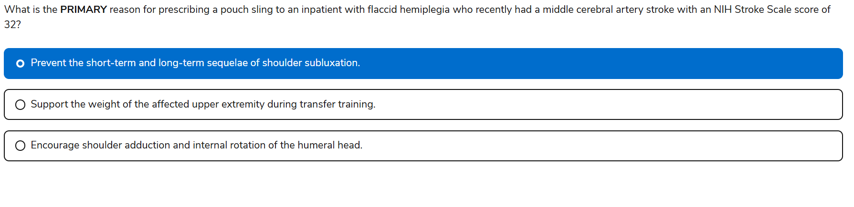

A NIH Stroke Scale score of 32 indicates a severe stroke, likely resulting in complete flaccidity of the affected side

The NIH Stroke Scale (NIHSS) ranges from 0 to 42, with higher scores indicating more severe neurological impairment. A score of 32 falls into the very severe category, often associated with:

• Dense hemiplegia (complete motor loss on one side)

• Profound sensory deficits

• Global aphasia or severe communication impairment

• Neglect or inattention to one side of the body

• Impaired consciousness or responsiveness

This level of impairment suggests extensive damage, likely involving both cortical and subcortical structures, especially if the stroke is in the middle cerebral artery (MCA) territory.

43. Knowledge

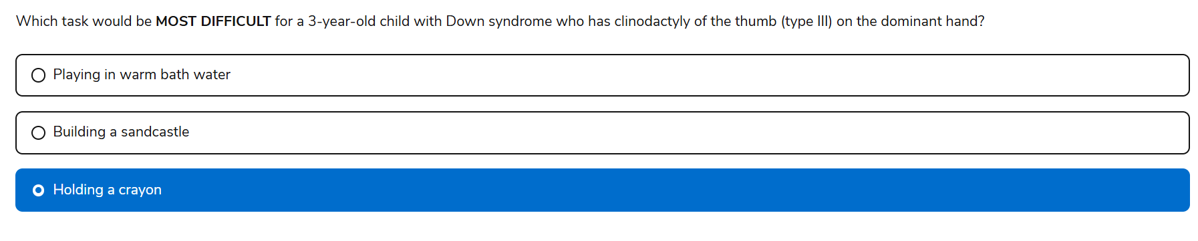

44. Knowledge cardiac rehab acute phase

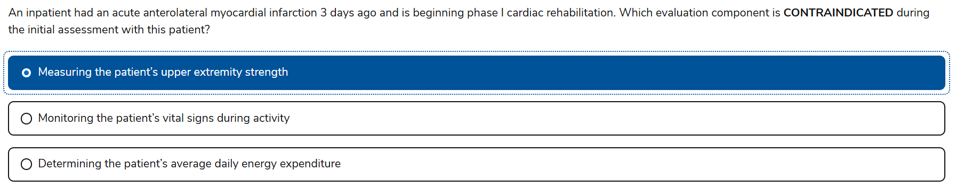

45. knowledge

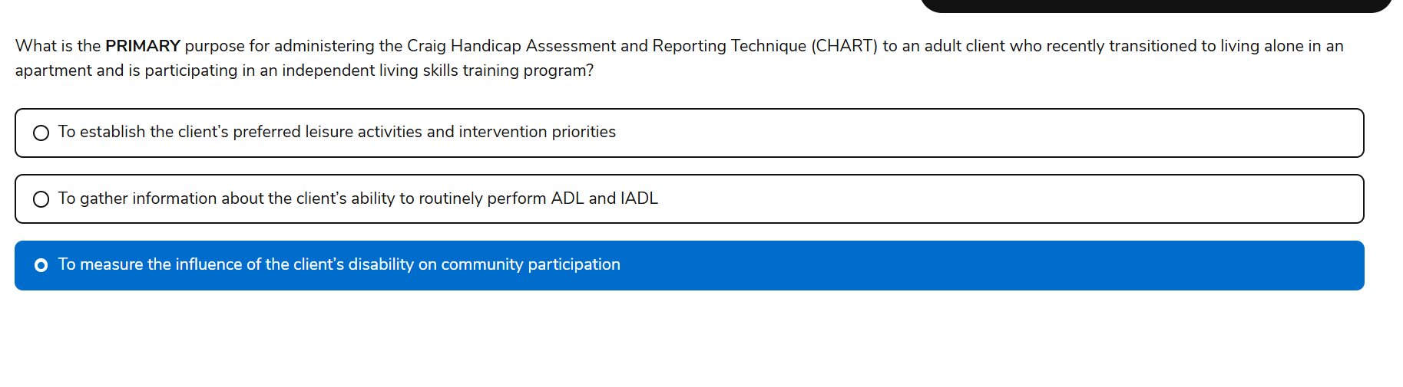

The **Craig Handicap Assessment and Reporting Technique (CHART)** is designed to:

* Measure how a **disability affects participation** in **major life domains**, including:
  + Physical independence
  + Mobility
  + Occupation
  + Social integration
  + Economic self-sufficiency
* It’s especially relevant for clients transitioning to **independent living**, where the focus shifts from basic function to **community engagement and autonomy**

**46. Knowledge wound care**

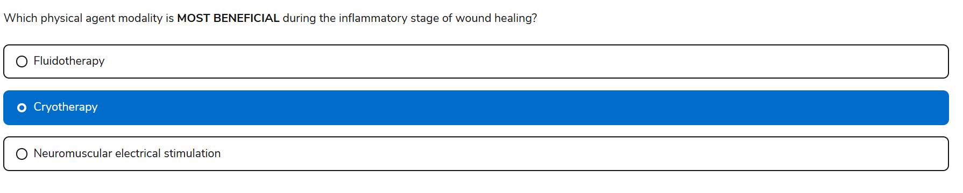

fluidotherapy - Provides **heat**, which increases circulation—not ideal during inflammation

-Use this at **proliferative and remodeling phases of wound healing**

47. Knowledge

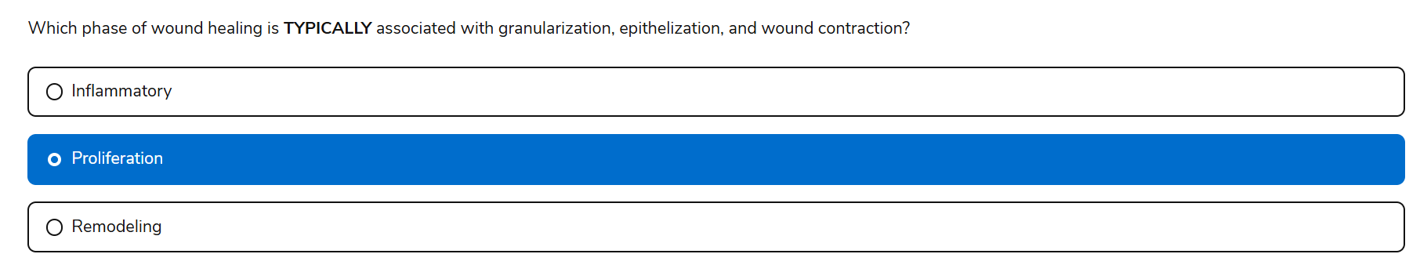

The proliferation phase is typically associated with:

• Granulation tissue formation (new capillaries, fibroblasts, extracellular matrix)

• Epithelialization (migration of epithelial cells across the wound bed)

• Wound contraction (myofibroblasts pulling wound edges together)

This phase usually occurs from day 4 to day 21 post-injury and is critical for tissue regeneration and closure.

## **🩹 Stages of Wound Healing (Physiological Phases)**

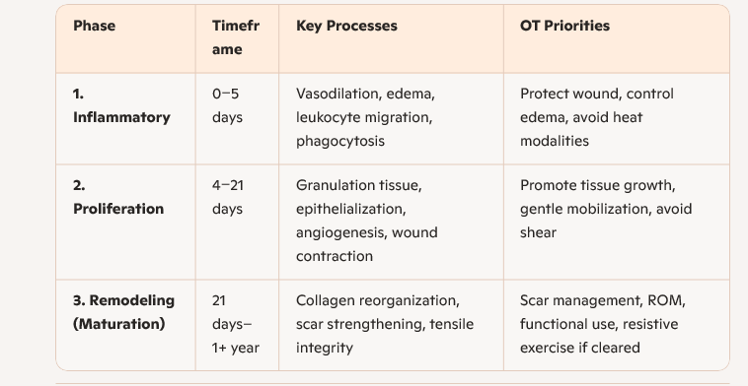

## **🔍 NBCOT-Focused Concepts to Know**

### **🧠 1. Modalities by Phase**

* **Inflammatory phase**:  
  + Use **cryotherapy** to reduce edema and pain
  + **Avoid heat** (e.g., fluidotherapy, paraffin)
  + No aggressive ROM or resistance
* **Proliferation phase**:  
  + Begin **gentle AROM**, **desensitization**, and **scar massage**
  + **Moist wound healing** is ideal (e.g., hydrocolloid dressings)
* **Remodeling phase**:  
  + Introduce **resistive exercise**, **scar mobilization**, and **functional retraining**
  + Use **compression garments**, **silicone sheets**, and **ultrasound** for scar control

### **🧪 2. Wound Types & OT Implications**

* **Pressure injuries**: Know staging (I–IV), positioning strategies, and offloading techniques
* **Surgical wounds**: Focus on **incision protection**, **ROM precautions**, and **scar management**
* **Burns**: Understand **depth classification**, **splinting needs**, and **contracture prevention**

### **🧼 3. Wound Care Principles**

* **Debridement**: OTs may assist with **non-selective methods** (e.g., whirlpool, wet-to-dry)
* **Infection signs**: Redness, warmth, purulence, odor—know when to refer
* **Documentation**: Describe wound **size, depth, color, exudate, odor, and periwound condition**

### **🧰 4. Splinting & Positioning**

* Prevent **contractures** and **skin breakdown**
* Use **anti-deformity positioning** for burns
* Monitor for **pressure points** under orthoses

### **📘 5. Assessment Tools**

* **Braden Scale**: Pressure injury risk
* **PUSH Tool**: Pressure Ulcer Scale for Healing
* **Visual analog scales** for pain and edema tracking

## **🧩 NBCOT Strategy Tip**

NBCOT loves to ask:

* *Which modality is contraindicated during the inflammatory phase?*
* *What intervention supports epithelialization?*
* *How should an OT manage a hypertrophic scar in the remodeling phase?*

So focus on **timing**, **modality selection**, and **functional goals** aligned with healing stages.

Would you like a printable wound care matrix that maps healing phases to OT interventions, modalities, and precautions? It could be a powerful anchor for both your NBCOT prep and clinical practice.

48. Task based

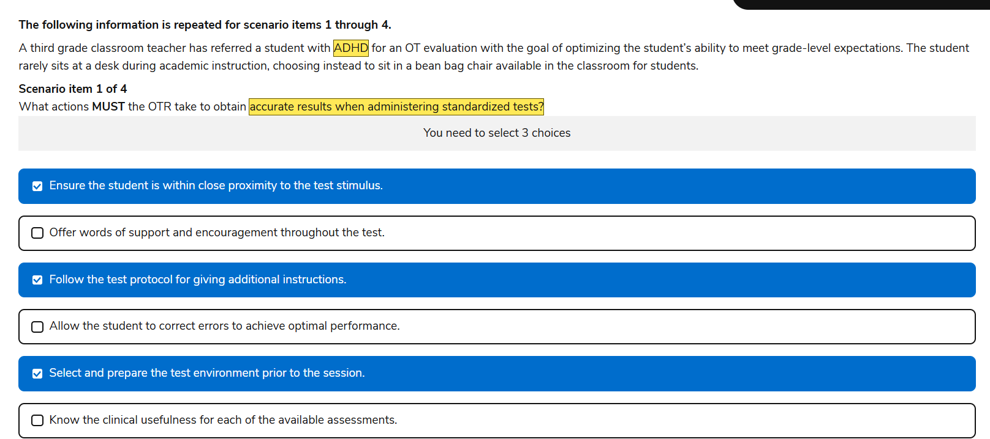

49. Knowledge

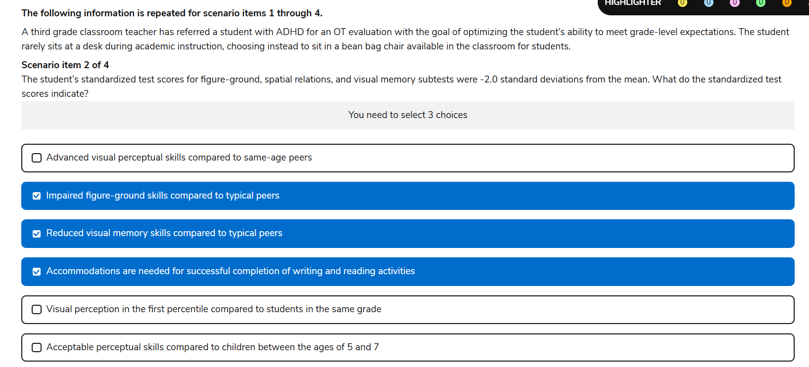

50. Task,

-C. Visual sequencing, task initiation, and step step learning for sequential picture cards

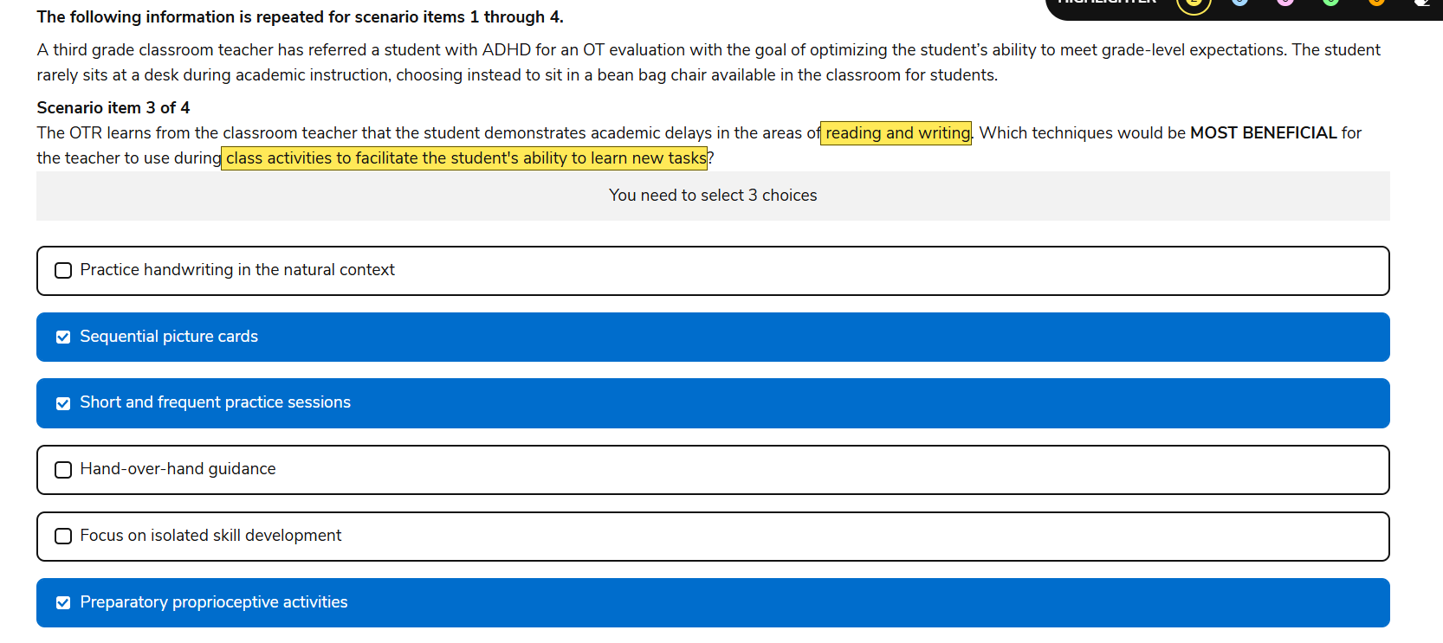

51.

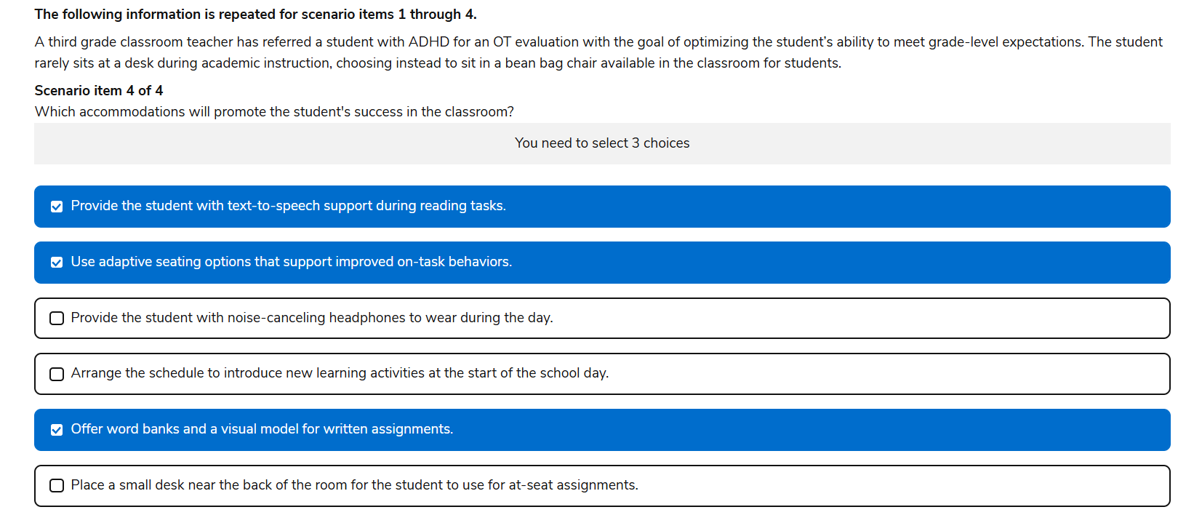

52. Knowledge

-antipsychotic meds

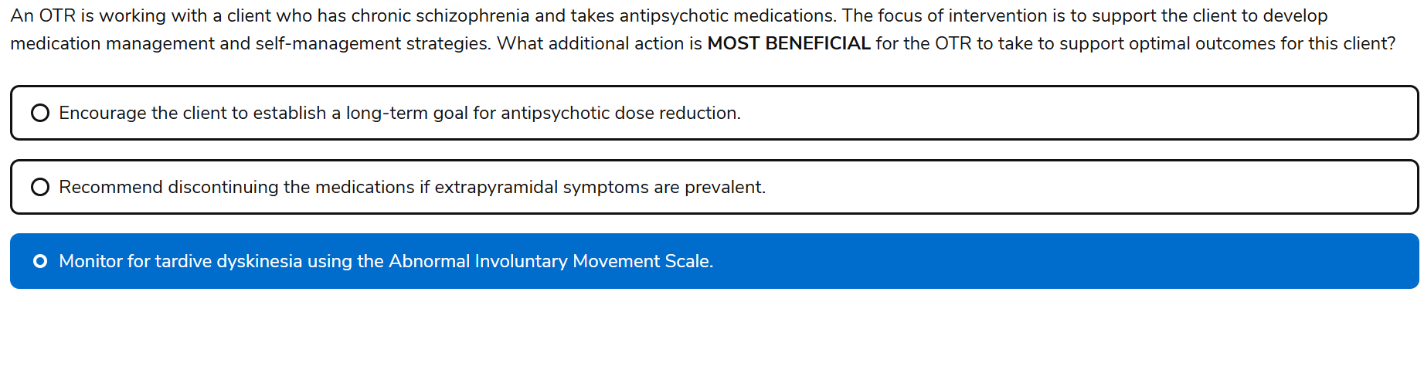

Yes Keely, your selected answer—**“Monitor for tardive dyskinesia using the Abnormal Involuntary Movement Scale”**—is absolutely **correct** ✅. This NBCOT question is designed to test your ability to integrate **medication side effect monitoring** into **functional OT practice**, especially when working with clients who have **chronic psychiatric conditions** like **schizophrenia**.

## **🧠 What NBCOT Is Testing**

This item assesses your ability to:

* Recognize the **functional implications** of long-term **antipsychotic medication use**
* Identify appropriate **clinical tools** for monitoring **movement disorders**
* Apply **client-centered intervention planning** that includes **health management and maintenance**
* Collaborate with interdisciplinary teams to support **medication adherence and safety**

## **✅ Why Your Answer Is Correct**

**Tardive dyskinesia (TD)** is a serious, often irreversible side effect of long-term antipsychotic use. It involves:

* **Involuntary, repetitive movements** (e.g., facial grimacing, tongue protrusion, limb twitching)
* Can interfere with **feeding**, **communication**, **social participation**, and **self-care**

The **Abnormal Involuntary Movement Scale (AIMS)** is:

* A **standardized tool** used to **screen and monitor TD symptoms**
* Often administered by OTs, nurses, or physicians in **mental health or long-term care settings**
* Helps guide **medication adjustments** and **intervention planning**

By using AIMS, the OTR supports:

* **Early detection** of movement disorders
* **Interdisciplinary communication** with prescribing providers
* **Client education** and **self-management strategies**

53. Knowledge

-Environment is important for transition identify barriers, goals for strategies, contextual understanding are key to optimizing outcomes

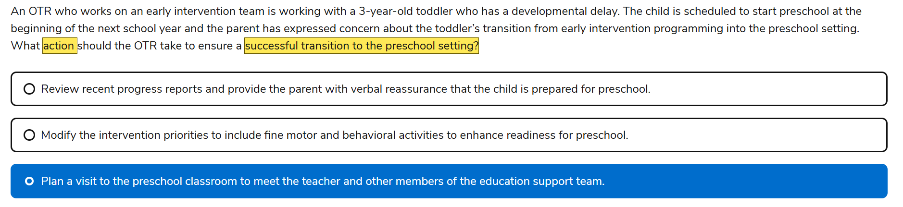

54.

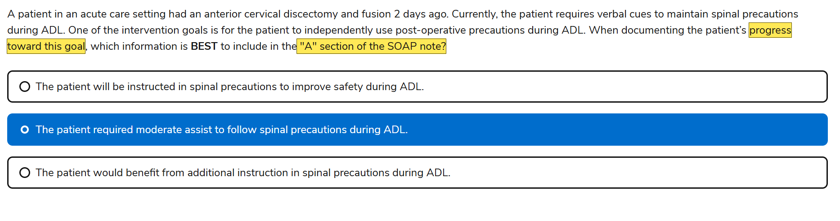

## **🧠 What NBCOT Is Testing**

This item evaluates your ability to:

* Apply correct **clinical documentation practices**
* Distinguish between **objective data** and **clinical interpretation**
* Use appropriate **language and structure** in SOAP notes
* Reflect **functional performance** and **progress toward goals**

## **✅ Why Your Answer Is Correct**

In the **Assessment section** of a SOAP note, the OTR should:

* Interpret the **significance** of the objective findings
* Describe the **level of assistance** required
* Reflect on the **client’s progress** toward goals

“The patient required moderate assist to follow spinal precautions during ADL” is:

* A **clinical judgment** based on observed performance
* Specific and measurable (moderate assist = quantifiable support)
* Directly related to the **intervention goal** of independent use of precautions

This statement helps guide future treatment planning and communicates clearly with the care team.

## **❌ Why the Other Options Are Incorrect**

| **Option** | **Why It’s Inappropriate for the "A" Section** |
| --- | --- |
| **“The patient will be instructed…”** | Future-oriented—belongs in the **Plan ("P")** section |
| **“The patient would benefit from…”** | Vague and speculative—doesn’t reflect actual performance or progress |

55.

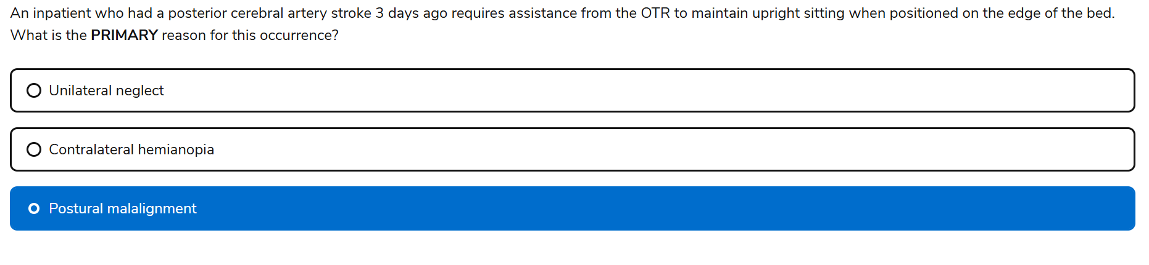

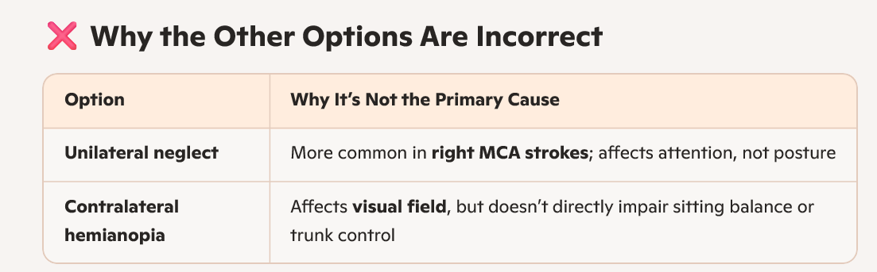

56.

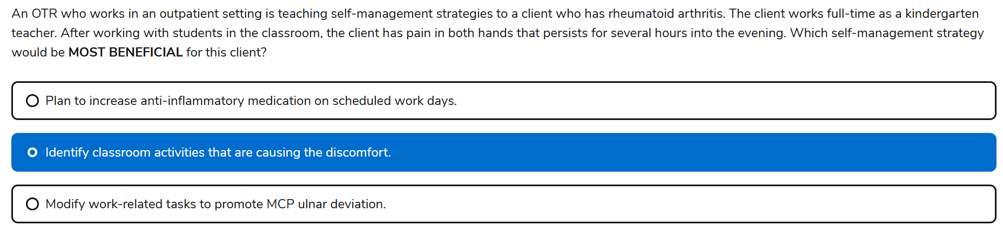

Yes Keely, your selected answer—**“Identify classroom activities that are causing the discomfort”**—is absolutely **correct** ✅. This NBCOT question is designed to assess your ability to apply **self-management strategies** for a client with **rheumatoid arthritis (RA)** in a **real-world occupational context**, especially one that involves **repetitive hand use** and **joint stress**.

## **🧠 What NBCOT Is Testing**

This item evaluates your ability to:

* Apply **client-centered problem solving**
* Use **activity analysis** to identify pain triggers
* Promote **self-management** and **joint protection principles**
* Integrate OT strategies into **daily routines and work environments**

## **✅ Why Your Answer Is Correct**

RA is a **chronic inflammatory condition** that affects the **small joints**, especially in the hands. For a kindergarten teacher, classroom tasks like:

* Cutting, writing, manipulating small objects
* Frequent lifting or gripping  
   can exacerbate **MCP joint inflammation** and pain.

By identifying which **specific classroom activities** are causing discomfort, the OTR can:

* Target those tasks for **modification or adaptation**
* Educate the client on **joint protection techniques**
* Reduce **flare-ups** and improve **functional endurance**

This approach is **collaborative**, **empowering**, and rooted in **activity analysis**—a core OT skill.

## **❌ Why the Other Options Are Incorrect**

| **Option** | **Why It’s Not Appropriate** |
| --- | --- |
| **Increase anti-inflammatory meds** | Outside OT scope—medication changes must be guided by a physician |
| **Promote MCP ulnar deviation** | This would **worsen joint deformity**—OTs aim to **prevent** ulnar drift, not encourage it |

## **📘 Textbook Tie-In**

* **Pedretti’s** and **TherapyEd** emphasize:
  + **Joint protection**, **energy conservation**, and **task modification**
  + Importance of **identifying aggravating activities** through **contextual analysis**
* OTPF-4 supports **health management** and **work participation** through **self-management strategies**

57.

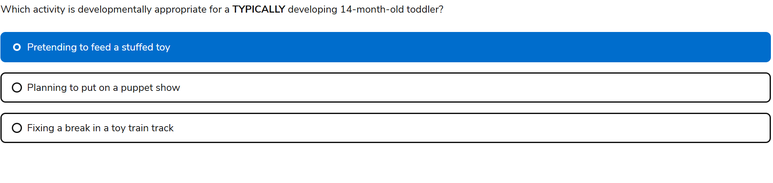

58.

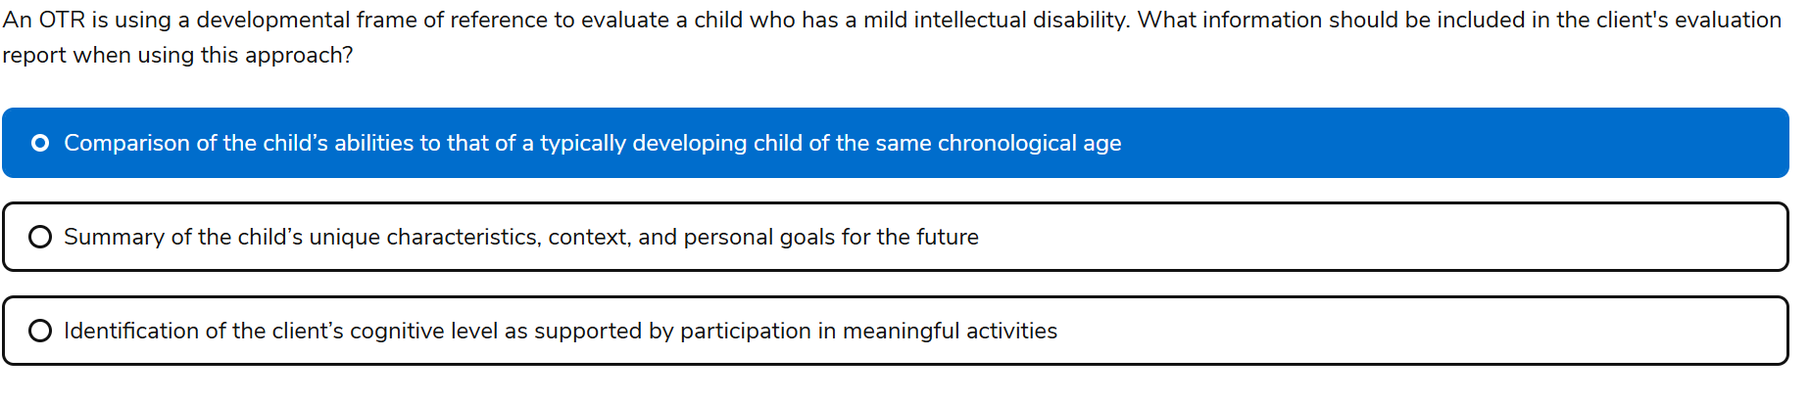

59.

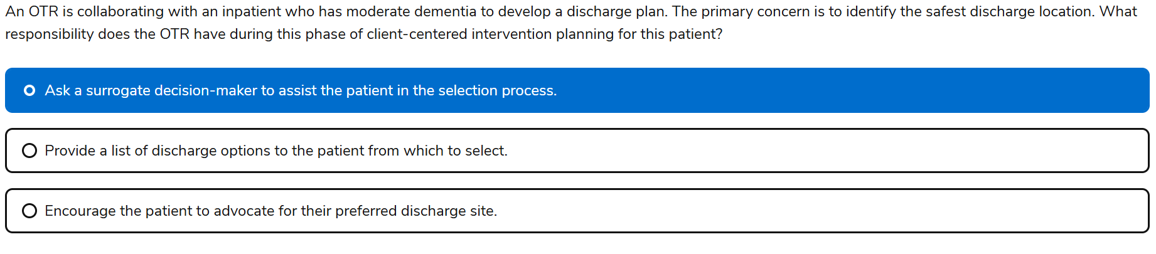

## **🧠 What NBCOT Is Testing**

This item assesses your ability to:

* Recognize when a client’s **cognitive status** limits their ability to make **safe, informed decisions**
* Apply **ethical and legal principles** around **surrogate decision-making**
* Prioritize **safety and support systems** in discharge planning
* Collaborate with **family members, caregivers, and interdisciplinary teams**

## **✅ Why Your Answer Is Correct**

A client with **moderate dementia** may:

* Have **impaired judgment**, **memory**, and **executive functioning**
* Be unable to fully understand or weigh the risks and benefits of discharge options
* Require support from a **legally authorized surrogate** (e.g., healthcare proxy, guardian, family member)

Involving a surrogate ensures:

* Decisions are made in the client’s **best interest**
* The discharge plan reflects **safety**, **support needs**, and **realistic expectations**
* The OTR remains within their **scope of practice**, facilitating—not directing—placement decisions

## **❌ Why the Other Options Are Less Appropriate**

| **Option** | **Why It’s Not the Best Choice** |
| --- | --- |
| **Provide a list of discharge options to the patient** | Assumes the patient has **full decision-making capacity**, which is unlikely with moderate dementia |
| **Encourage the patient to advocate for their preferred site** | May lead to **unsafe or unrealistic choices** due to cognitive limitations—OT must prioritize safety and support |

60. Task based

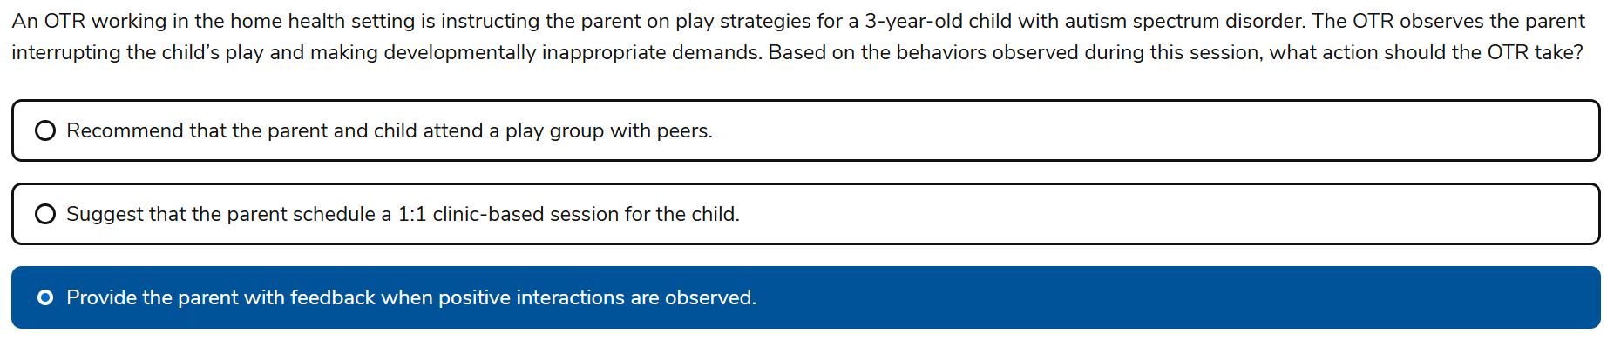

61. Knowledge

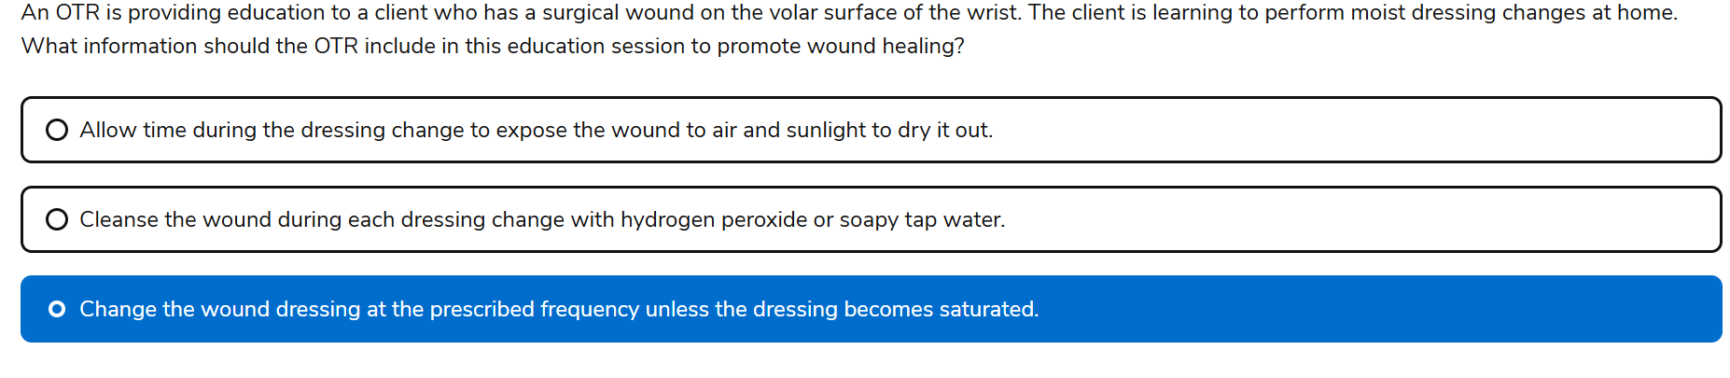

## **🧠 What NBCOT Is Testing**

This item assesses your ability to:

* Promote **optimal wound healing** through proper **dressing protocols**
* Educate clients on **safe, effective home care routines**
* Recognize **contraindicated practices** that could delay healing or cause harm
* Apply **clinical reasoning** to support **self-management strategies**

## **✅ Why Your Answer Is Correct**

Changing the dressing at the **prescribed frequency**—or sooner if saturated—is essential because:

* It maintains a **moist wound environment**, which:
  + Promotes **epithelialization**
  + Reduces **infection risk**
  + Speeds up **tissue regeneration**
* Saturated dressings can:
  + Harbor **bacteria**
  + Break down surrounding skin
  + Delay healing

This approach reflects **best practice** in wound care and aligns with **OT’s role in client education and health management**.

## **❌ Why the Other Options Are Incorrect**

| **Option** | **Why It’s Contraindicated** |
| --- | --- |
| **Expose wound to air and sunlight** | Drying out the wound delays healing and increases infection risk—moist wound healing is preferred |
| **Cleanse with hydrogen peroxide or soapy tap water** | Hydrogen peroxide is **cytotoxic**—it damages healthy tissue and impairs healing; soapy water is **non-sterile** and may introduce contaminants |

62. Knowledge

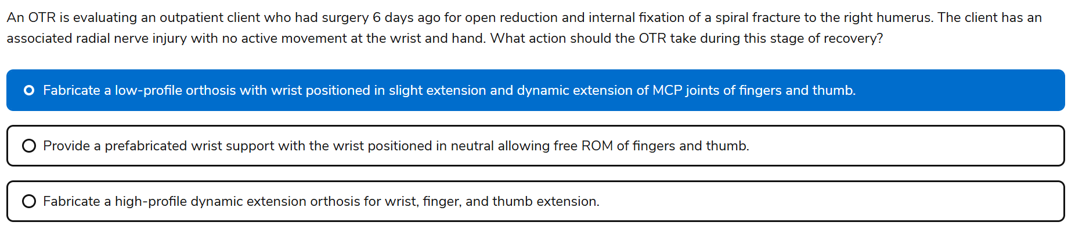

## **🧠 What NBCOT Is Testing**

This question assesses your ability to:

* Apply **orthotic principles** for **radial nerve palsy**
* Understand **post-operative protocols** following **ORIF of humeral fractures**
* Select the **appropriate orthosis** based on **nerve injury, healing stage, and functional goals**
* Integrate **clinical reasoning** with **intervention planning**

## **✅ Why Your Answer Is Correct**

The client is **6 days post-op** from ORIF of a **spiral humeral fracture** with **radial nerve injury**—no active wrist or hand movement.

* **Radial nerve injury** causes:
  + **Wrist drop** (loss of wrist extension)
  + **MCP joint extension loss** (digits and thumb)
* A **low-profile dynamic extension orthosis**:
  + Supports **wrist in slight extension** to prevent contracture
  + Provides **dynamic MCP extension** to maintain joint mobility and prevent deformity
  + Is **less bulky**, ideal for **early outpatient use**
  + Encourages **functional positioning** while protecting healing tissues

This orthosis supports **nerve recovery**, prevents **secondary complications**, and promotes **functional hand use** during healing.

## **❌ Why the Other Options Are Incorrect**

| **Option** | **Why It’s Not Appropriate** |
| --- | --- |
| **Prefabricated wrist support in neutral** | Doesn’t address MCP extension loss; neutral wrist positioning may lead to contractures and doesn’t support functional hand posture |
| **High-profile dynamic extension orthosis** | Too aggressive for early post-op phase; may interfere with healing or be uncomfortable for outpatient use at day 6 |

63. Knowledge

-Primitive Reflexes

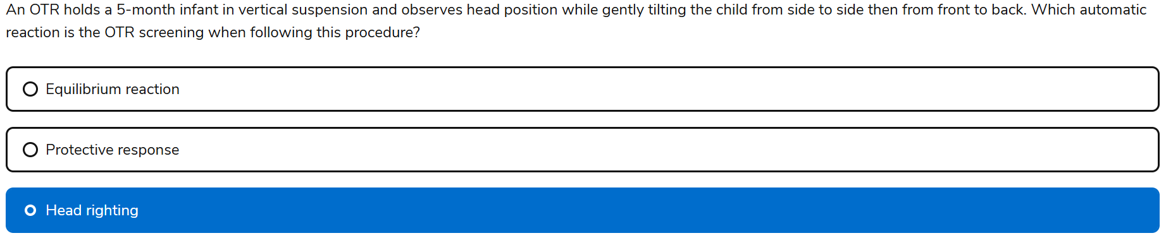

64. Task based

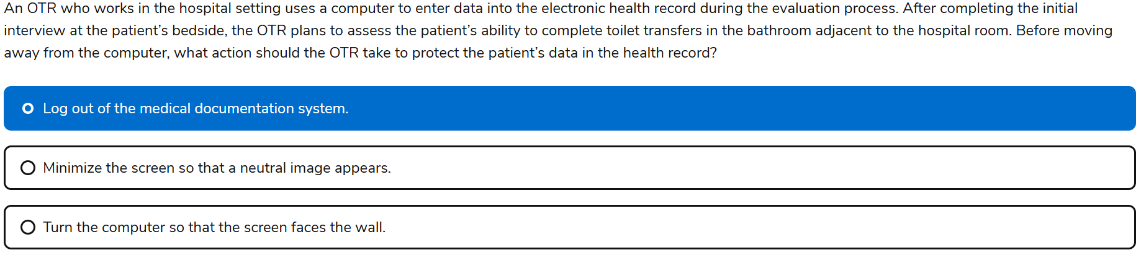

65. Knowlege

-PICO questions

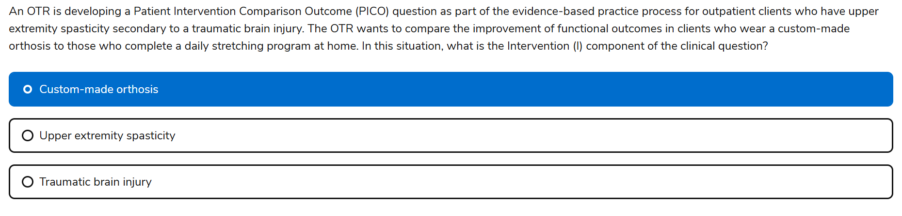

* **P** = Patient/Population
* **I** = Intervention
* **C** = Comparison
* **O** = Outcome

66. Knowledge

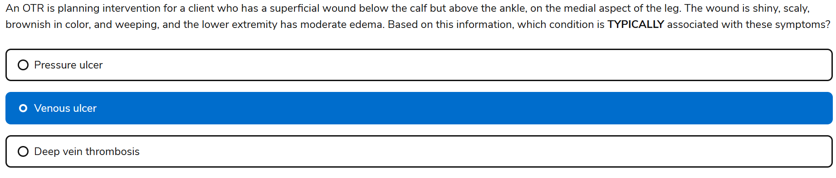

## **✅ Why “Venous Ulcer” Is Correct**

The wound description—**shiny, scaly, brownish, weeping**, with **moderate edema** on the **medial lower leg**—is classic for a **venous stasis ulcer**.

* **Venous ulcers** typically present:
  + On the **medial aspect of the lower leg**, especially above the ankle
  + With **brownish discoloration** due to **hemosiderin staining**
  + As **shallow, irregular wounds** that may **weep**
  + With **moderate to severe edema** from **venous insufficiency**
* These ulcers result from **poor venous return**, leading to **fluid accumulation** and **skin breakdown**

This presentation is **distinct** from other wound types and requires **compression therapy**, **elevation**, and **skin protection**—all areas where OT plays a role in education and positioning.

## **❌ Why the Other Options Are Incorrect**

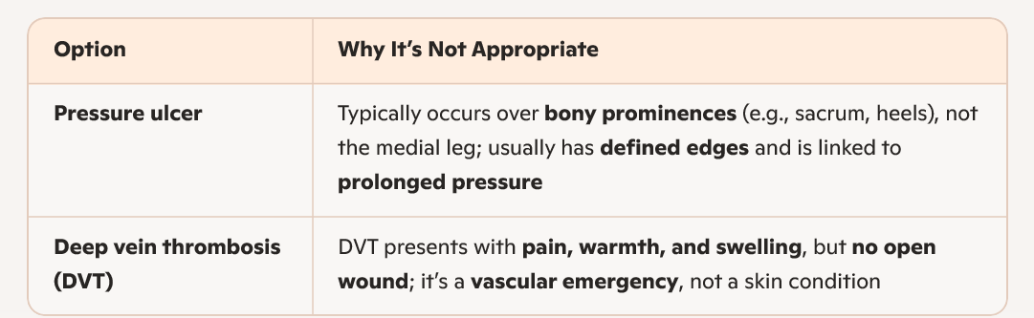

67. knowledge

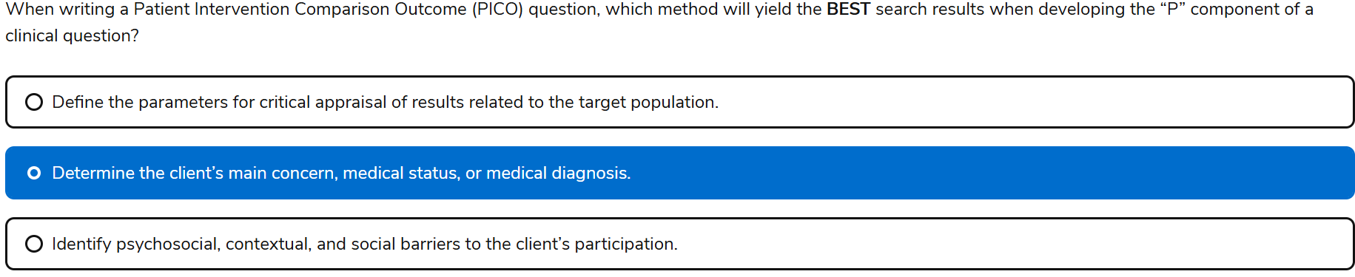

P= patient/ population,

* The **P** in PICO should define:
  + The **population or condition** being studied
  + The **main concern, diagnosis, or demographic** relevant to the clinical question

68. Knowledge

-Spinal precautions

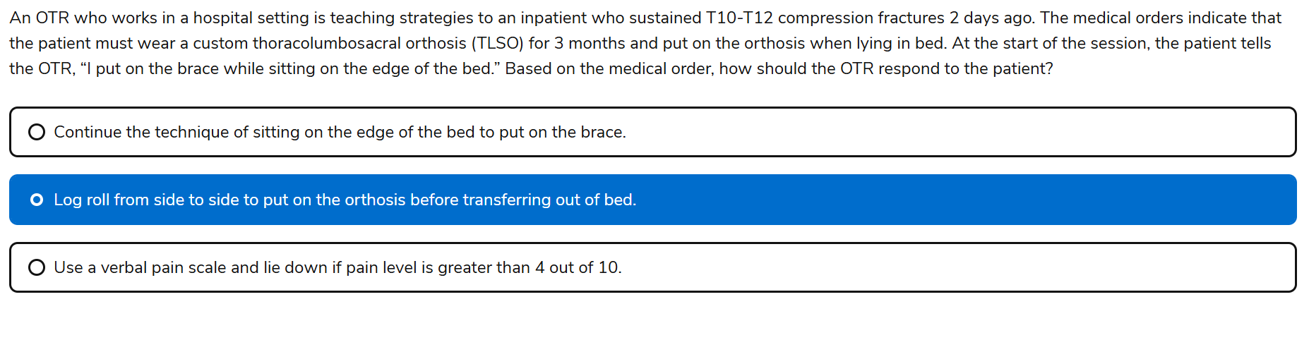

69. Knowledge

-Wound care dressings

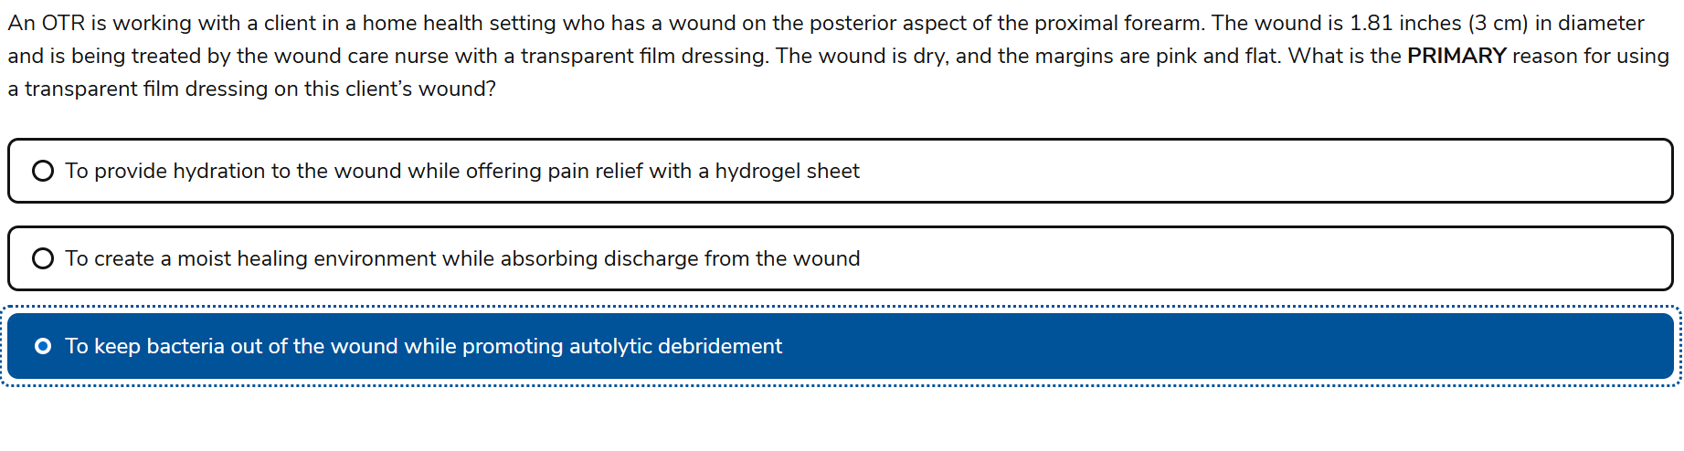

Transparent film dressings are:

• Semi-permeable: They allow oxygen in but block bacteria and moisture out

• Occlusive: They trap the body’s natural enzymes and moisture, promoting autolytic debridement (the body’s own way of breaking down necrotic tissue)

• Best for dry, shallow wounds with no to minimal exudate, like the one described

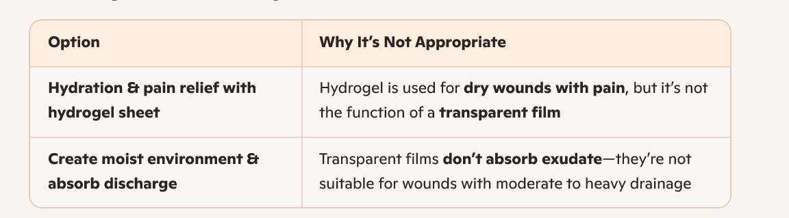

70. Knowledge

-Wheelchair

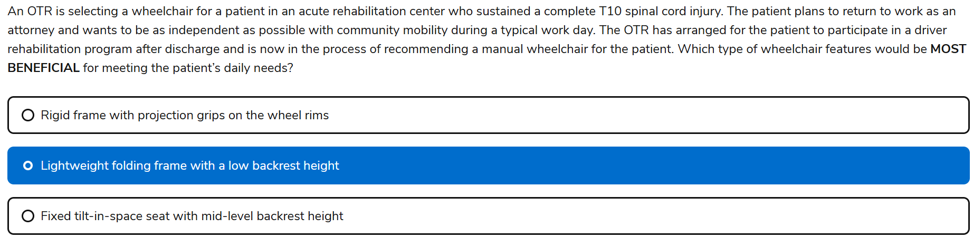

So the wheelchair must be:

* **Lightweight**: Easier for independent propulsion and car transfers
* **Folding frame**: Allows for compact storage in vehicles
* **Low backrest height**: Promotes **trunk mobility** and **independent transfers**, especially into/out of a car

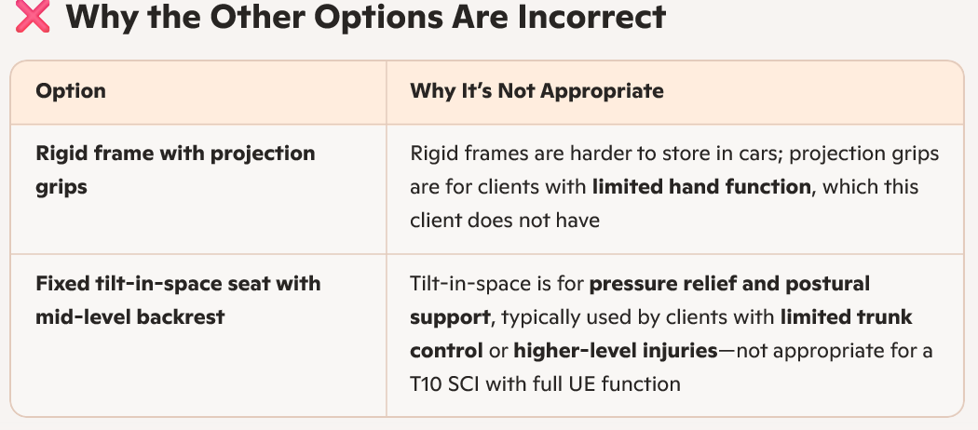

71. Knowledge

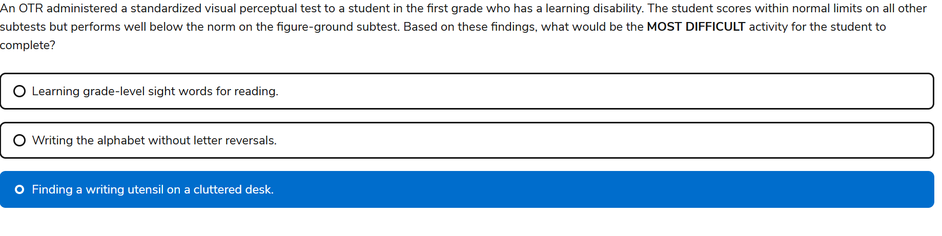

72. Knowledge

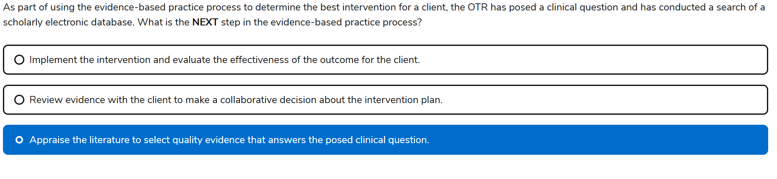

Yes, Keely—the highlighted answer **“Appraise the literature to select quality evidence that answers the posed clinical question”** is absolutely correct ✅

### **🧠 Why This Is the Right Answer:**

This question is testing your understanding of the **evidence-based practice (EBP) process**, which follows a structured sequence. After you’ve posed a clinical question and searched scholarly databases, the **next essential step** is to **critically appraise the literature**—not jump straight into implementation or client collaboration.

Here’s the classic EBP flow:

1. **Pose a clinical question** (often using PICO format)
2. **Search for relevant evidence**
3. **Appraise the evidence** ← ✅ *This is the step being tested*
4. **Apply the evidence in collaboration with the client**
5. **Evaluate the outcomes**

73. knowledge

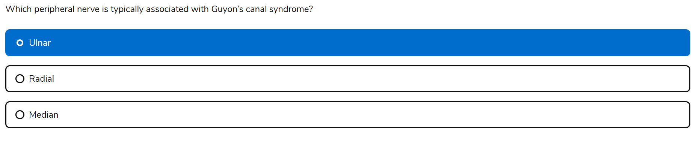

74. Knowledge

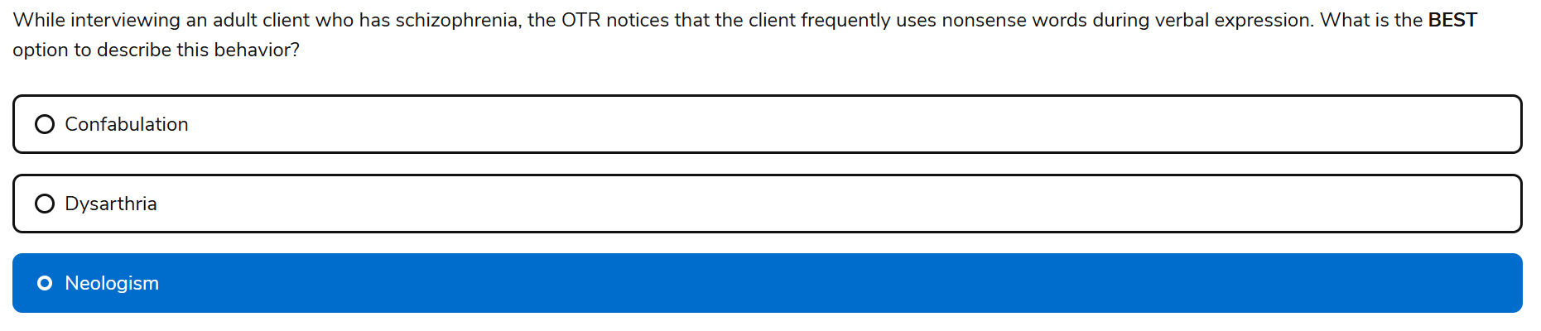

Yes, Keely—the highlighted answer **“Neologism”** is absolutely correct ✅

### **🔍 Why It’s Right for NBCOT:**

* The question describes a client with **schizophrenia** who uses **nonsense words** during verbal expression.
* **Neologism** is the textbook term for this behavior: the creation of **new, made-up words** that are **unintelligible to others** but may hold meaning for the individual.
* It’s a hallmark of **disorganized thought and speech**, often seen in schizophrenia and sometimes in severe brain injury or aphasia.

### **🧠 Quick Breakdown of the Other Options:**

| **Option** | **Why It’s Incorrect** |
| --- | --- |
| **Confabulation** | False memories, often seen in TBI or dementia—not nonsense words |
| **Dysarthria** | Motor speech disorder—slurred or slow speech, not invented words |

75. Task based

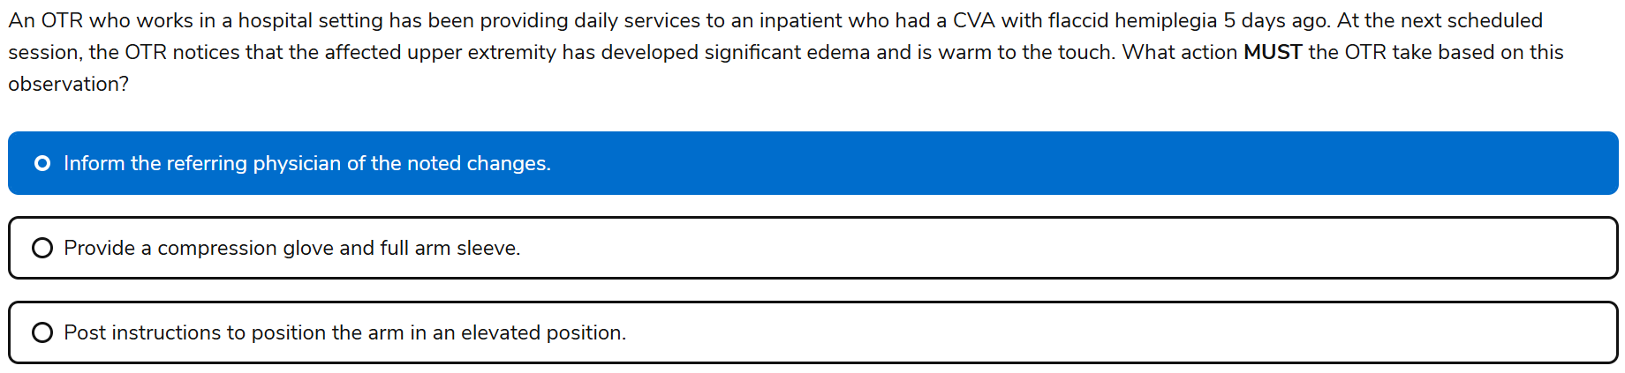

**\*Act within your scope of practice** and refer appropriately

76. task

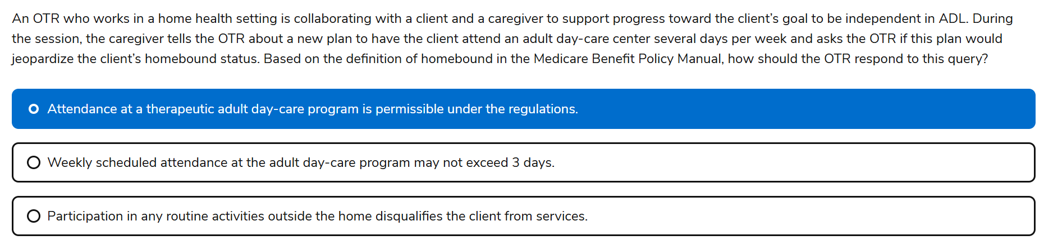

### **📘 Correct Answer and Rationale**

The correct answer is:  
 **1. Attendance at a therapeutic adult day-care program is permissible under the regulations.**

Your selected answer (**3. Participation in any routine activities outside the home disqualifies the client from services**) is a **common trap**—and here's why:

#### **🔍 Medicare’s Definition of Homebound (per Chapter 7 of the Medicare Benefit Policy Manual):**

A person is considered homebound if:

* Leaving the home requires **considerable and taxing effort**
* Absences from the home are **infrequent**, **of short duration**, or for **healthcare-related reasons**

👉 **Therapeutic adult day-care attendance** is explicitly allowed **if it’s medically necessary** and doesn’t contradict the taxing nature of leaving home.

So, attending a day-care center **does not automatically disqualify** someone from being considered homebound—**especially** if it's part of a therapeutic plan and the individual still meets the criteria of needing substantial effort to leave home.

77. Knowledge

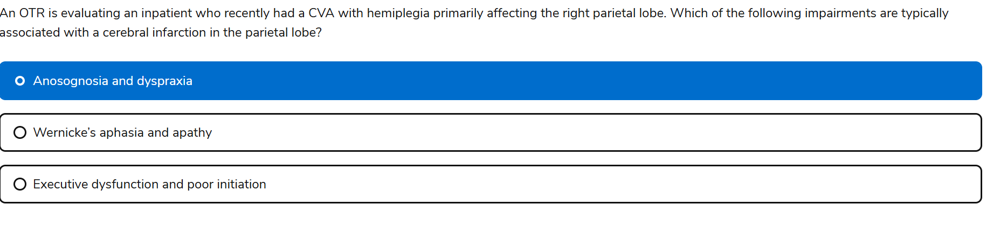

✅ Correct Answer:

**1. Anosognosia and dyspraxia**

These are classic signs of **right parietal lobe damage**:

* **Anosognosia**: Lack of awareness of one’s deficits—common in right hemisphere strokes.
* **Dyspraxia**: Difficulty with motor planning, often linked to parietal lobe dysfunction.

These impairments can severely impact safety, independence, and rehab engagement—so recognizing them is crucial.

## **🧠 Brain Lobes & What You Need to Know for NBCOT**

| **Lobe** | **Primary Functions** | **Common Impairments (CVA or TBI)** |
| --- | --- | --- |
| **Frontal Lobe** | - Executive function (planning, judgment, problem-solving)  - Motor control (precentral gyrus)  - Speech production (Broca’s area – left hemisphere)  - Emotional regulation | - Poor initiation  - Impulsivity  - Perseveration  - Broca’s aphasia (non-fluent)  - Apathy or disinhibition |
| **Parietal Lobe** | - Sensory integration  - Spatial awareness  - Body schema  - Motor planning (praxis) | - **Right parietal**: Anosognosia, neglect, dyspraxia  - **Left parietal**: Agraphia, acalculia, apraxia |
| **Temporal Lobe** | - Auditory processing  - Language comprehension (Wernicke’s area – left hemisphere)  - Memory (hippocampus) | - Wernicke’s aphasia (fluent but nonsensical speech)  - Auditory agnosia  - Memory deficits |
| **Occipital Lobe** | - Visual processing | - Visual field cuts  - Visual agnosia  - Difficulty recognizing objects or faces (prosopagnosia) |
| **Cerebellum** | - Coordination  - Balance  - Motor learning | - Ataxia  - Dysmetria  - Intention tremor |
| **Brainstem** | - Vital functions (breathing, heart rate)  - Cranial nerve nuclei | - Dysphagia  - Altered consciousness  - CN deficits |

## **🧩 How NBCOT Might Frame These Concepts**

NBCOT loves to test this content through:

* **Case-based scenarios**: “An OTR is evaluating a client post-CVA with damage to the right parietal lobe…”
* **Functional implications**: “Which deficits would most likely interfere with dressing?”
* **Safety concerns**: “Which impairment increases fall risk or poor judgment?”
* **Communication deficits**: “Which aphasia type is present based on the client’s speech?”

## **🧠 Quick Mnemonics to Help You Remember**

* **F**rontal = **F**unctions, **F**ocus, **F**iltering behavior
* **P**arietal = **P**osition in space, **P**raxis
* **T**emporal = **T**alk and **T**unes (language + auditory)
* **O**ccipital = **O**ptics (vision)

78. Task

-OTPF know process skills (cognitive) to answer this question

-debilitation mean physical weakness, lack of energy

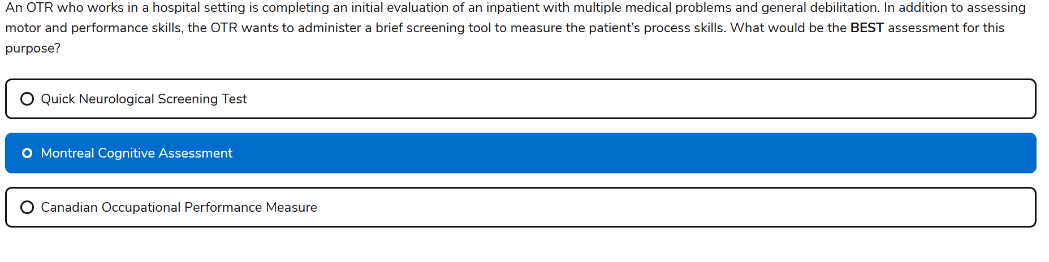

**Montreal Cognitive Assessment (MoCA)**

This would be the best choice for evaluating **process skills** in a medically complex inpatient. Why?

* MoCA assesses **executive function**, **attention**, **memory**, **visuospatial skills**, and **language**—all key components of **process skills**.
* It’s brief, standardized, and sensitive to **mild cognitive impairment**, which is common in medically complex populations.
* It gives you a **functional cognitive snapshot** that can guide your intervention planning.
* sequencing , memory

**Canadian Occupational Performance Measure (COPM)**

This is **not the best choice** for measuring **process skills** in this context. Here's why:

* COPM is a **client-centered outcome measure** that identifies **occupational performance priorities** and tracks **perceived changes over time**.
* It’s **not designed to objectively assess process skills** like sequencing, problem-solving, or attention during task performance.
* It’s more appropriate for **goal setting and measuring client satisfaction**, not for initial skill-based evaluation in medically complex inpatients.

79. Task

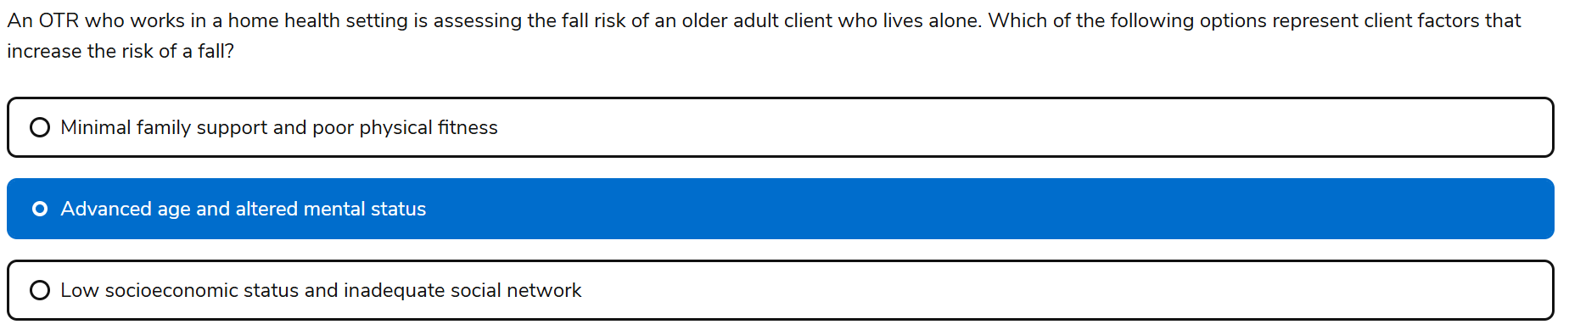

80.

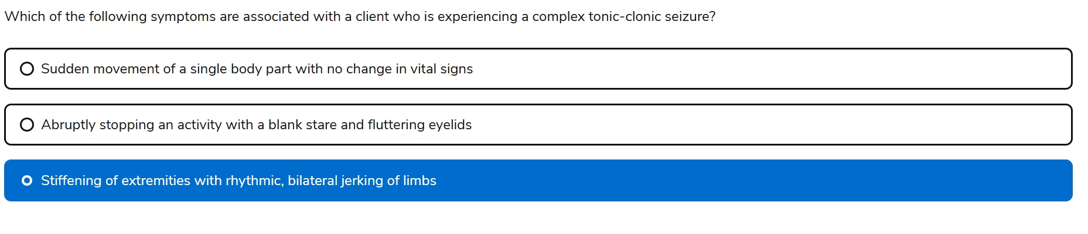Yes Keely, your selected answer—  
 **"Stiffening of extremities with rhythmic, bilateral jerking of limbs"**—is absolutely correct ✅

## **🧠 What NBCOT Is Testing Here**

This question is designed to assess your ability to:

* **Recognize seizure types based on clinical presentation**
* Apply **clinical reasoning** to identify symptoms that require immediate safety precautions
* Understand how **neurological conditions** impact occupational performance and intervention planning

NBCOT wants to know: Can you quickly identify a **tonic-clonic seizure** and respond appropriately in a real-world setting?

## **🔍 Why Your Answer Is Correct**

A **tonic-clonic seizure** (formerly called "grand mal") has two distinct phases:

| **Phase** | **Symptoms** |
| --- | --- |
| **Tonic** | Sudden loss of consciousness, stiffening of muscles |
| **Clonic** | Rhythmic, bilateral jerking of limbs |

These seizures often last 1–3 minutes and may be followed by confusion, fatigue, or incontinence. Safety is paramount—OTs must ensure the client is protected from injury during and after the episode.

## **🚫 Why the Other Options Are Incorrect**

| **Option** | **Why It’s Not Correct** |
| --- | --- |
| **1. Sudden movement of a single body part with no change in vital signs** | Describes a **simple motor seizure** (e.g., focal myoclonic), not tonic-clonic. No loss of consciousness or bilateral involvement. |
| **2. Abruptly stopping an activity with a blank stare and fluttering eyelids** | Classic signs of an **absence seizure** (petit mal), typically seen in children. Brief and subtle, not tonic-clonic. |

## **🧩 Study Tip**

Want to lock this in? I can build you a **printable seizure comparison chart** that maps:

* Seizure types
* Key symptoms
* OT safety protocols
* Postictal considerations

81. Knowledge

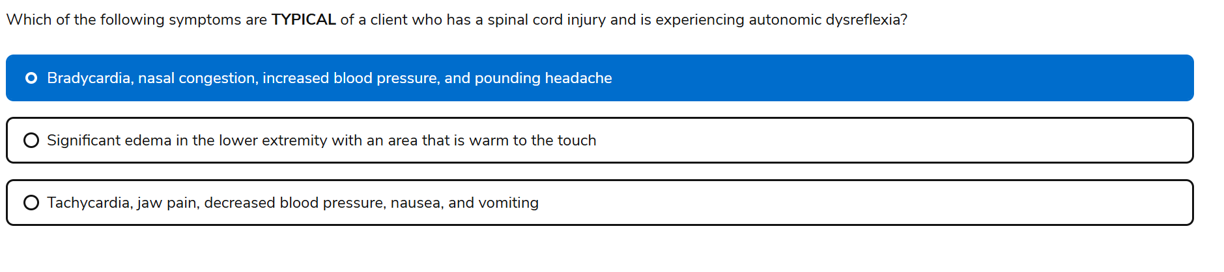

Here’s a crisp breakdown for you, Keely—perfect for NBCOT prep and clinical recall. These two conditions are often confused, but they’re **polar opposites in blood pressure response** and demand **opposite OT interventions**.

## **⚡ Autonomic Dysreflexia (AD)**

Occurs in clients with **SCI at or above T6** due to a **noxious stimulus** below the level of injury (e.g., full bladder, bowel impaction, tight clothing).

### **🔺 Symptoms:**

* **Sudden, severe hypertension** (↑ BP)
* **Bradycardia** (↓ HR)
* **Pounding headache**
* **Flushed skin and sweating above lesion level**
* **Goosebumps below lesion level**
* **Nasal congestion**
* **Blurred vision**
* **Anxiety or feeling of doom**

### **🛑 OT Response:**

* **Sit client upright immediately** to lower BP
* **Remove triggering stimulus** (check catheter, loosen clothing, etc.)
* **Alert medical team**

## **🔻 Orthostatic Hypotension (OH)**

Occurs when blood pressure **drops suddenly** due to **positional changes** (e.g., lying to sitting or standing), common in SCI due to impaired autonomic regulation.

### **🔻 Symptoms:**

* **Dizziness or lightheadedness**
* **Pale face**
* **Nausea**
* **Blurred vision**
* **Fainting or near-syncope**
* **Fatigue or weakness**
* **Tachycardia** (↑ HR)

### **🛑 OT Response:**

* **Recline client immediately**
* **Elevate legs**
* **Monitor vitals**
* Encourage **slow position changes** during transfers

82. Knowledge

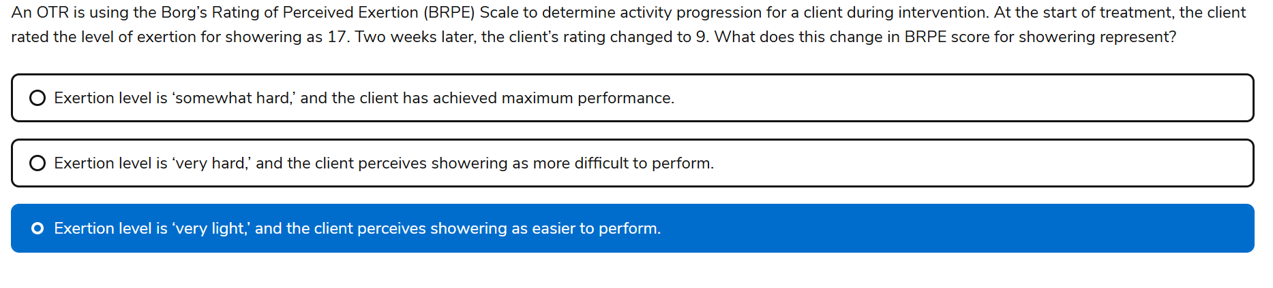

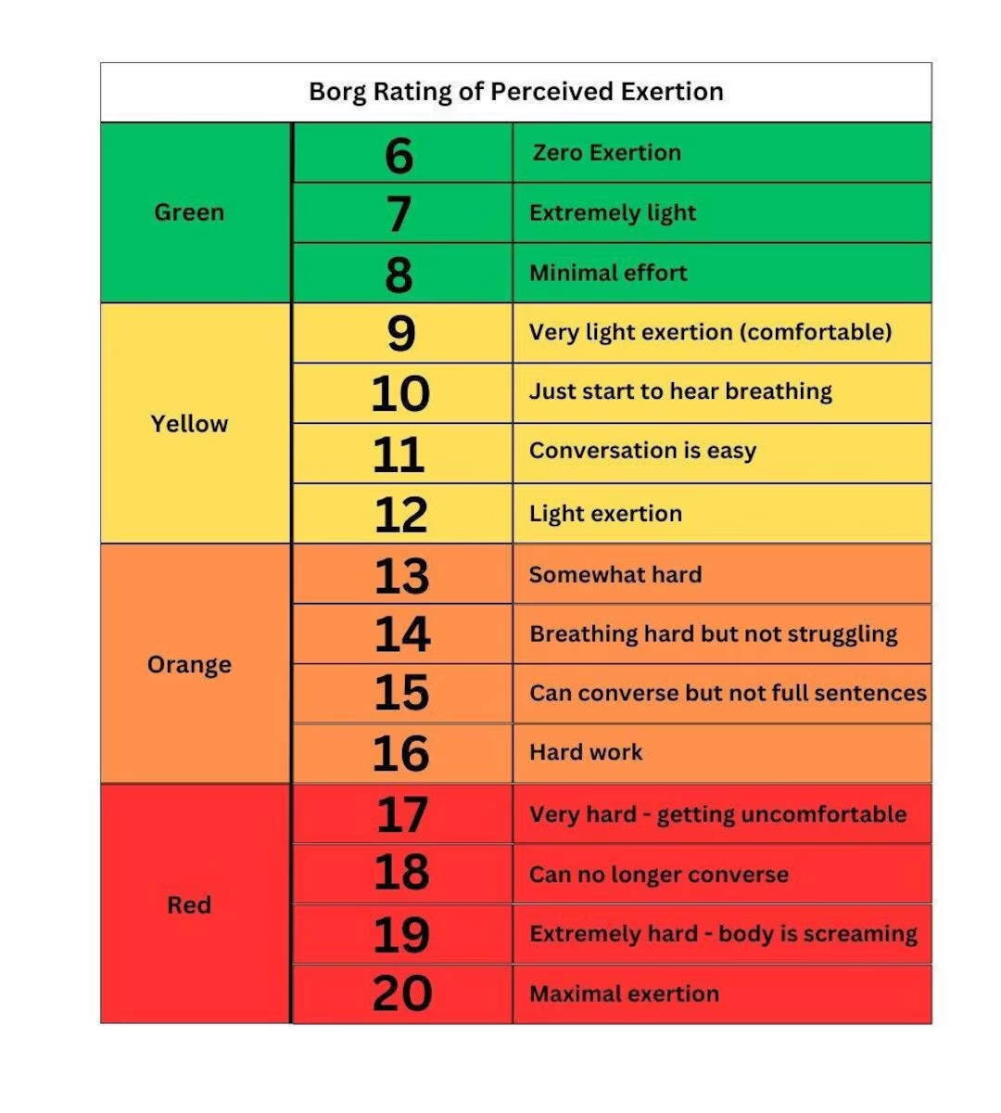

83. Knowledge

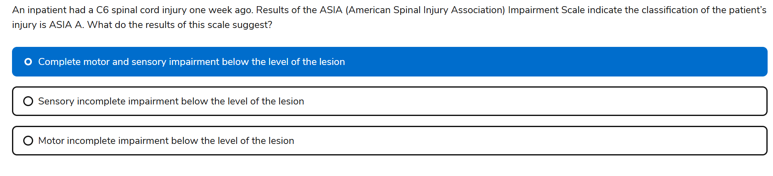

Complete motor and sensory ASIA A

Sensory incomplete ASIA B

Motor incomplete ASIA C

Motor incomplete: Motor preserved; more than half of key muscles below the level of injury have a muscle grade of >_ 3 (active movement against gravity)

*Clients with ASIA D often have:

* **Good potential for ambulation**, especially with assistive devices
* **Partial voluntary control** of bowel and bladder
* **Improved upper extremity function**, depending on the level of injury
* **Greater independence in ADLs and mobility**

84. Knowledge

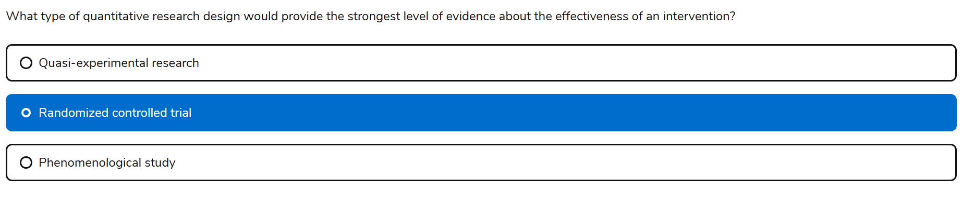You got it, Keely! Here's a clean, printable-style chart that breaks down **quantitative research designs**—tailored for NBCOT prep and clinical reasoning. It mirrors the format of the qualitative chart, but focuses on **measurable data**, **intervention testing**, and **levels of evidence**.

## **📊 Quantitative Research Designs in OT**

| **Design Type** | **Purpose** | **Key Features** | **Example in OT** | **Evidence Level** |
| --- | --- | --- | --- | --- |
| **Randomized Controlled Trial (RCT)** | Test effectiveness of an intervention | Random assignment, control group, high internal validity | Comparing CIMT vs. standard OT for stroke rehab | Level I (highest) |
| **Quasi-Experimental** | Test intervention without full control | No randomization, may lack control group | Studying sensory diets in schools without random group assignment | Level II |
| **Cohort Study** | Observe outcomes over time | Follows a group with shared characteristics | Tracking fall risk in older adults using home mods | Level II–III |
| **Case-Control Study** | Compare groups with/without outcome | Retrospective, matched groups | Comparing children with/without ASD on fine motor delays | Level III |
| **Cross-Sectional Study** | Snapshot of variables at one time | No follow-up, descriptive or correlational | Surveying OT students’ stress levels during fieldwork | Level III–IV |
| **Descriptive Study** | Describe characteristics or behaviors | No intervention, often survey-based | Documenting ADL performance in adults with MS | Level IV |
| **Correlational Study** | Examine relationships between variables | No causation, uses statistical analysis | Relationship between grip strength and dressing independence | Level IV |

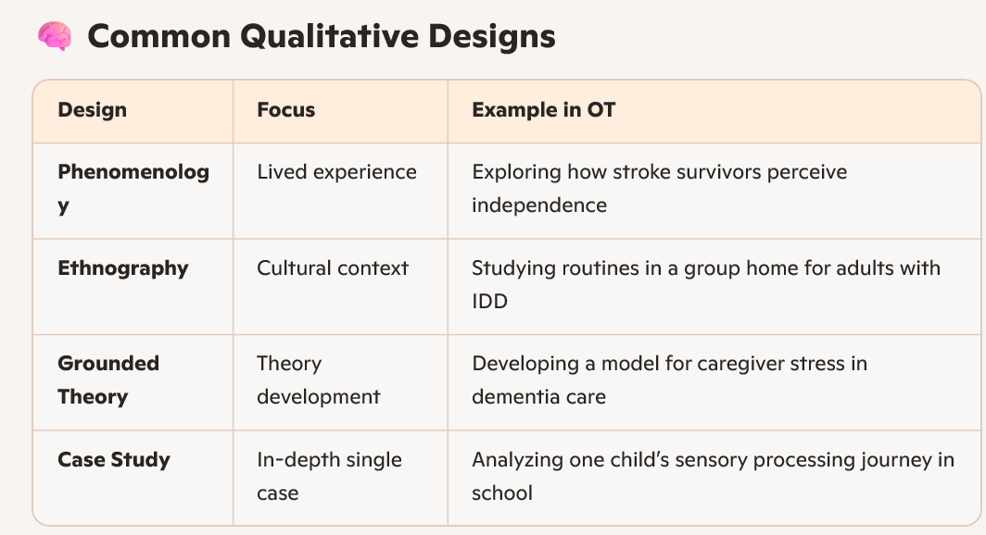

85. Knowledge

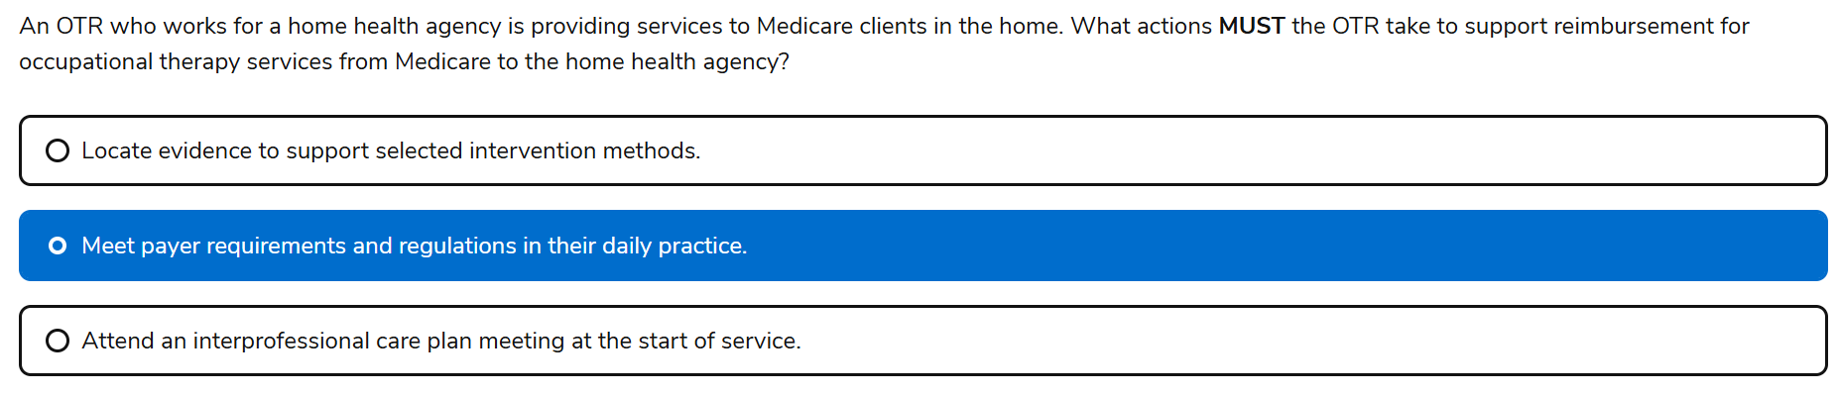

86. Task

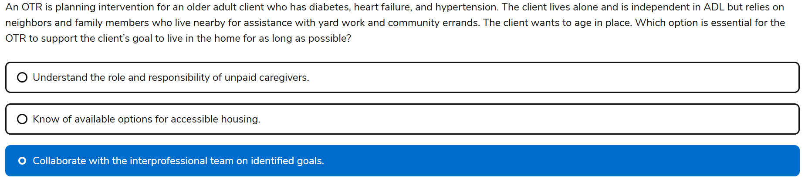

🏡 Aging in Place: Core Concepts

🔹 Definition:

The ability to live in one’s own home and community safely, independently, and comfortably, regardless of age, income, or ability level.

🔹 OT’s Role:

Occupational therapists help make this possible by:

* **Modifying the environment** (e.g., grab bars, ramps, lighting)
* **Training in ADLs/IADLs** (e.g., dressing, cooking, medication management)
* **Promoting health management** (e.g., chronic condition routines)
* **Supporting social participation** (e.g., transportation, leisure activities)
* **Educating caregivers and coordinating with the interprofessional team**

87. Knowledge

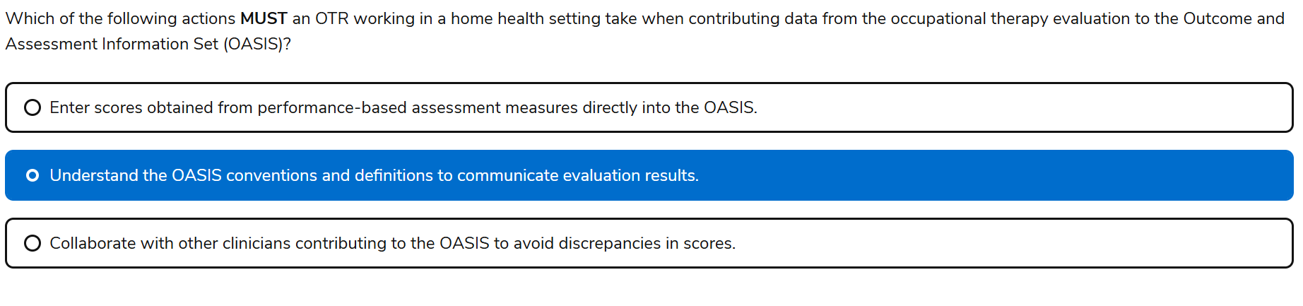

✅ Why the Correct Answer Matters

“Understand the OASIS conventions and definitions to communicate evaluation results”

* OASIS uses **standardized response options** and **specific definitions** for each item
* OTRs must **interpret their clinical findings** and **code them accurately**
* This ensures consistency across disciplines and supports **Medicare compliance**

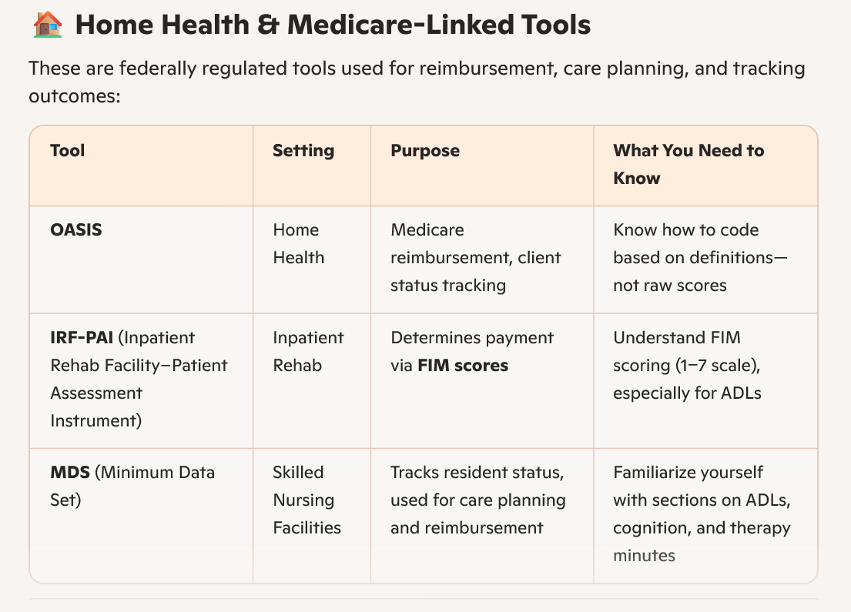

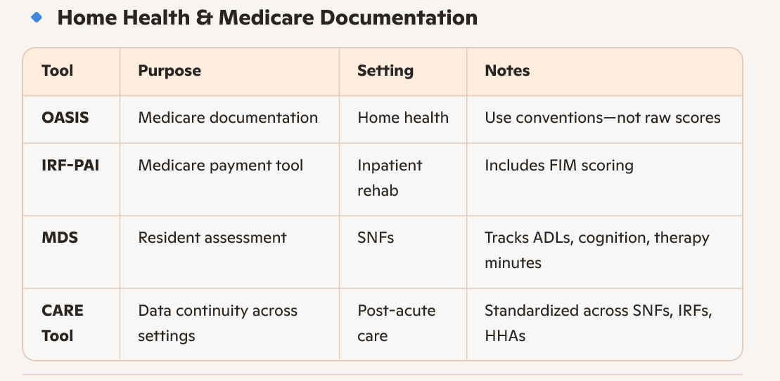

88. Knowledge

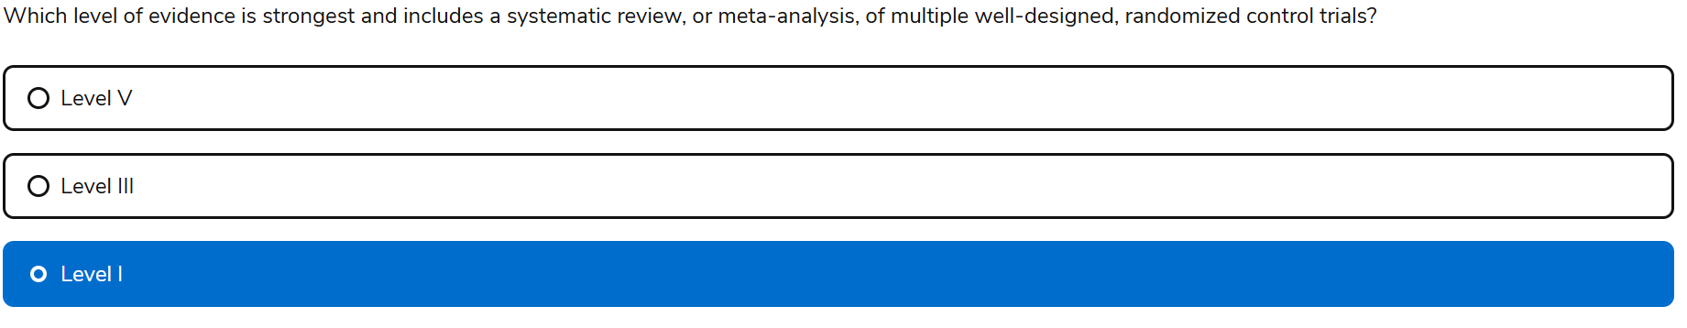

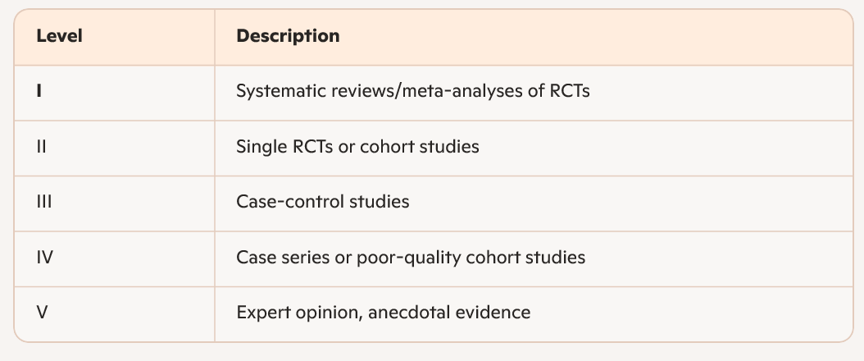

89. Task based

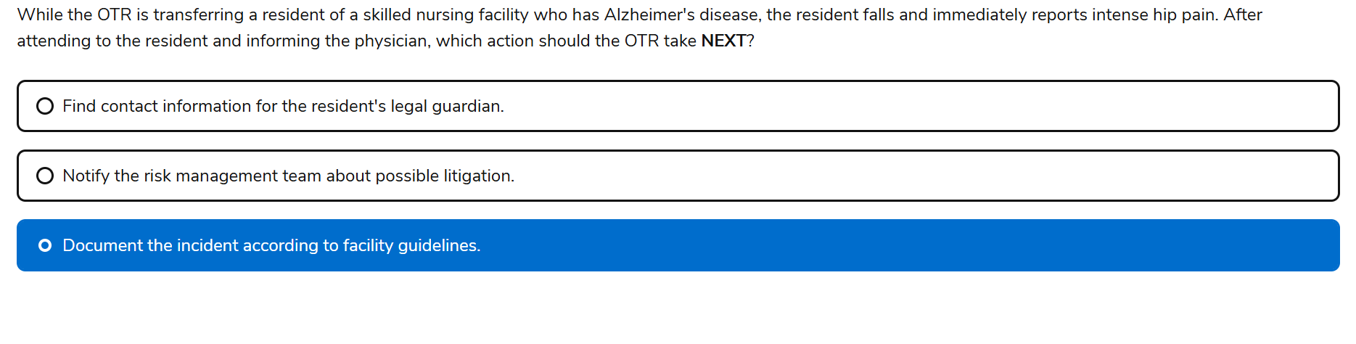

90. Knowledge

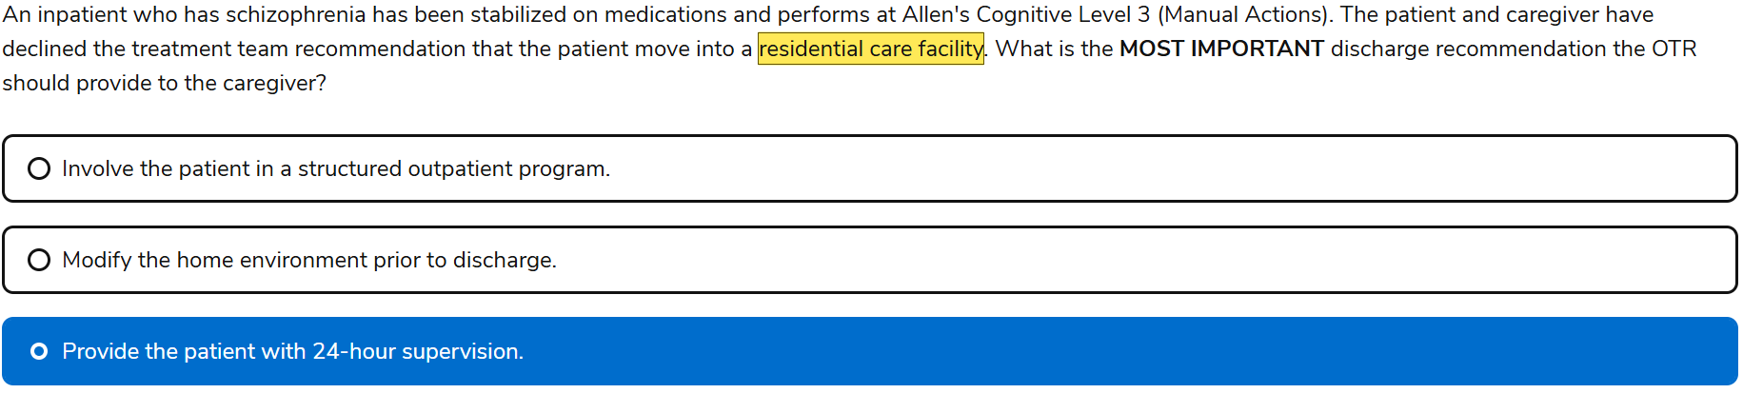

🧩 Why “24-Hour Supervision” Is the MOST Important Recommendation

The patient is functioning at **Allen Level 3: Manual Actions**, which means:

* They can perform **repetitive tasks with tactile cues**
* They **lack safety awareness**, **problem-solving**, and **goal-directed behavior**
* They cannot live independently or manage basic self-care without **constant supervision**

**Importance:** So even if the patient and caregiver decline residential care, the **minimum requirement** for safe discharge is **24-hour supervision**. It’s the **non-negotiable baseline** for someone at ACL 3.

91. Knowledge

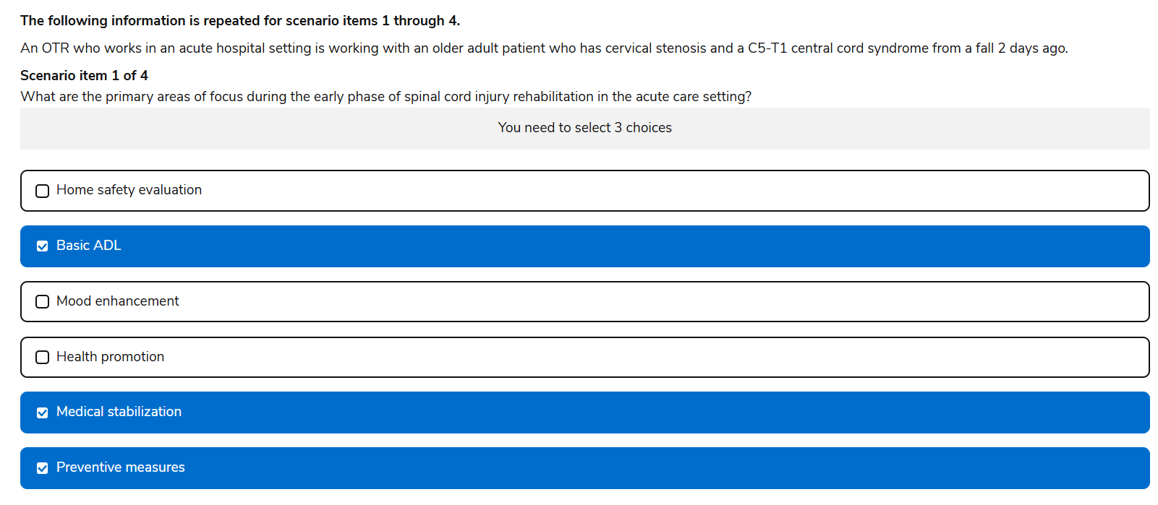

## **🧠 What NBCOT Is Testing**

This question assesses your ability to:

* Prioritize **early-phase goals** in acute SCI management
* Understand the **timeline of rehabilitation** across settings
* Apply **clinical staging** to intervention planning
* Distinguish between **acute care**, **inpatient rehab**, and **discharge planning**

## **✅ Correct Early-Phase Priorities**

1. **Medical Stabilization**
   * Absolutely essential in the first 48–72 hours post-injury
   * Includes monitoring vitals, respiratory function, and preventing secondary complications
   * Especially critical in **central cord syndrome**, where motor deficits may be more severe in the upper extremities
2. **Basic ADL**
   * Early OT involvement focuses on **bed mobility**, **grooming**, and **feeding**
   * Promotes independence and prevents learned helplessness
   * Also helps assess **functional potential** and guides rehab goals
3. **Preventive Measures** ✅ (This should replace home safety evaluation)  
   * Includes **skin integrity**, **positioning**, **DVT prevention**, and **joint protection**
   * These are foundational to SCI recovery and begin immediately in acute care

## **❌ Why “Home Safety Evaluation” Isn’t Ideal Yet**

* This is typically addressed **later**, during **inpatient rehab** or **discharge planning**
* At 2 days post-injury, the client is still medically unstable and not ready for home transition
* Premature focus on discharge can **detract from immediate clinical priorities**

92. Knowledge

-Central Cord Syndrome

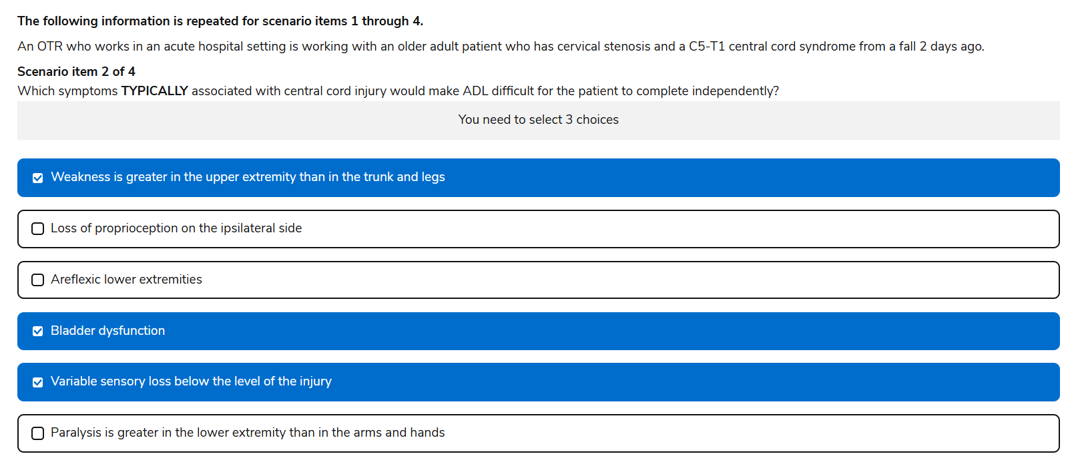

## **🧠 What Is Brown-Séquard Syndrome?**

Brown-Séquard Syndrome results from a **hemisection** (one-sided lesion) of the spinal cord, often due to:

* **Penetrating trauma** (e.g., stab or gunshot wounds)
* **Tumors**, **disc herniation**, **MS**, or **ischemia**

## **🧩 Classic Symptom Pattern**

| **Side of Lesion** | **Deficits** | **Why It Matters for ADLs** |
| --- | --- | --- |
| **Ipsilateral (same side)** | ✅ Loss of **motor function** and **proprioception** | Affects coordinated movement, balance, and fine motor control |
| **Contralateral (opposite side)** | ✅ Loss of **pain and temperature sensation** | Safety risk—client may not detect injury or burns |

This asymmetrical presentation is **textbook BSS** and a favorite on NBCOT for differential diagnosis.

## **🛠️ Functional Implications**

* **ADLs**: Difficulty with dressing, grooming, and transfers due to unilateral weakness and sensory loss
* **Safety**: Risk of injury on the side with impaired pain/temp sensation
* **Mobility**: Often good prognosis—**75–90% regain ambulation**

## **🧪 OT Evaluation & Intervention**

NBCOT expects you to know how to:

* Evaluate **MMT**, **proprioception**, **pain/temp**, and **discriminatory touch**
* Use tools like the **Barthel Index (ADL only)**, **FIM (ADL)**, or **CARE (used across multiple settings) NBCOT TIP= standardize patient data across post-acute care settings**, or one that supports **Medicare payment reform**, CARE is your answer.  
   It’s more about data continuity than direct clinical decision-making.
* Recommend **adaptive equipment** and **early mobilization**
* Address **fall prevention**, **psychosocial support**, and **tone management**

93. knowledge

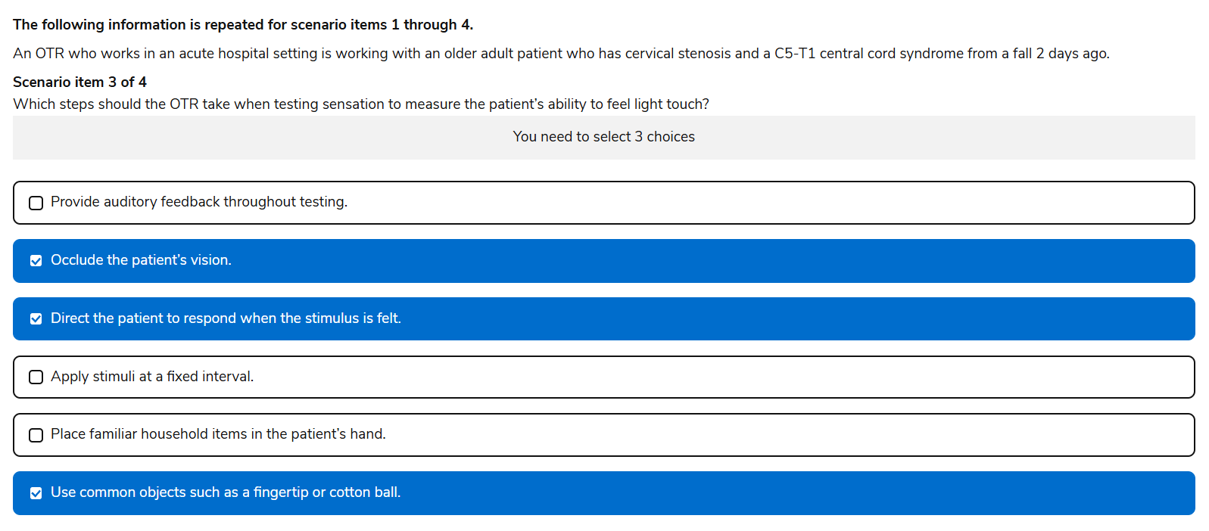

94. knowledge

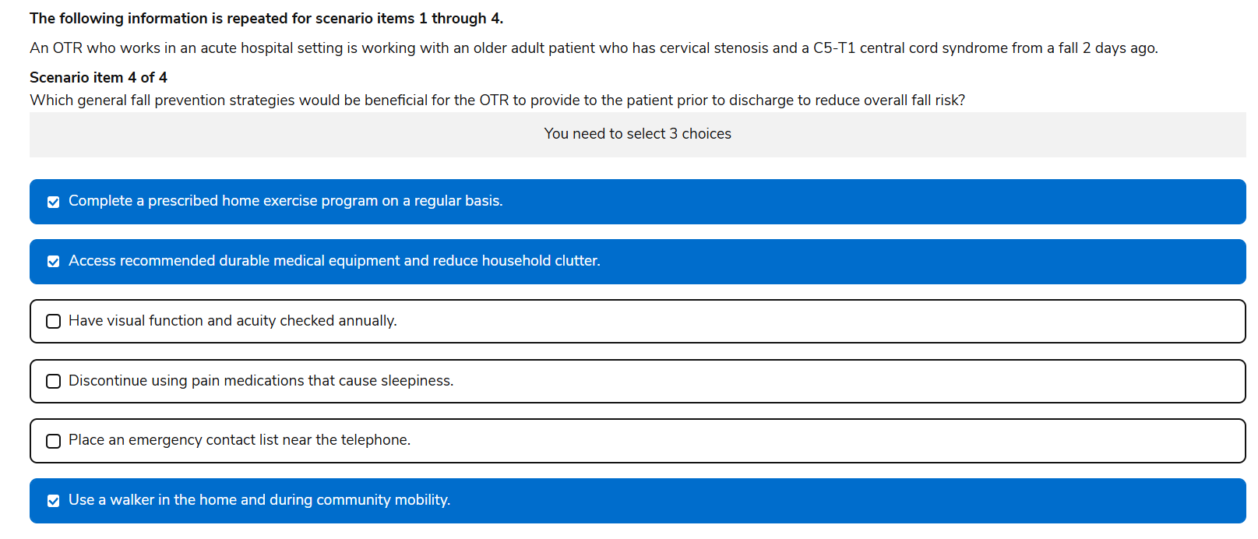

95. Knowledge

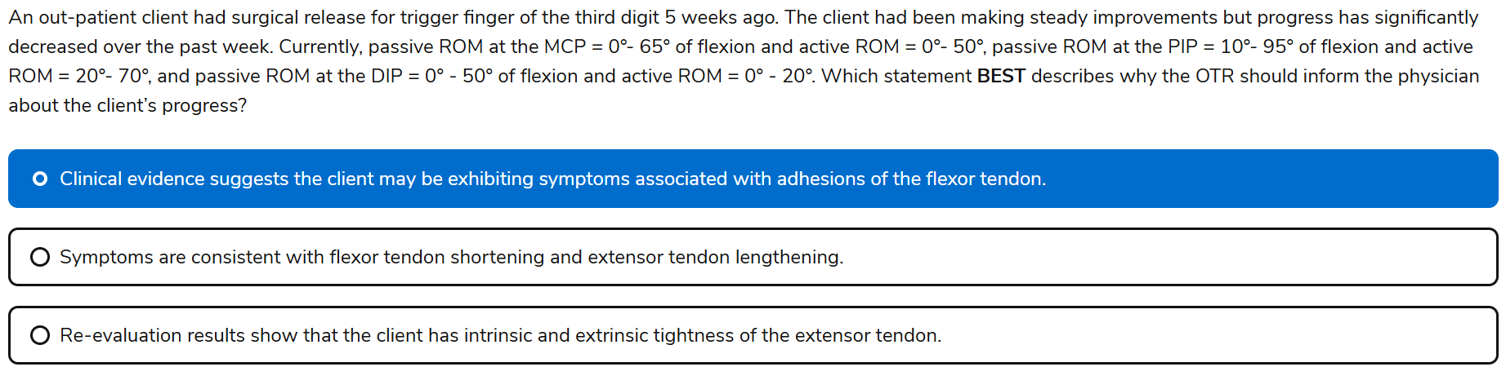

96. Task based

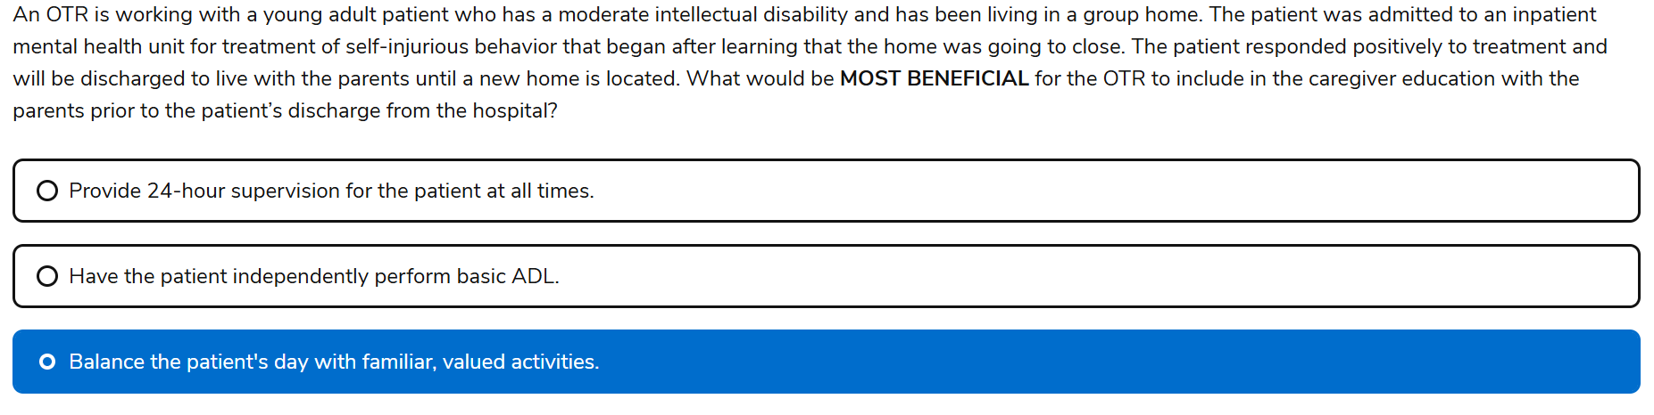

97. Task based

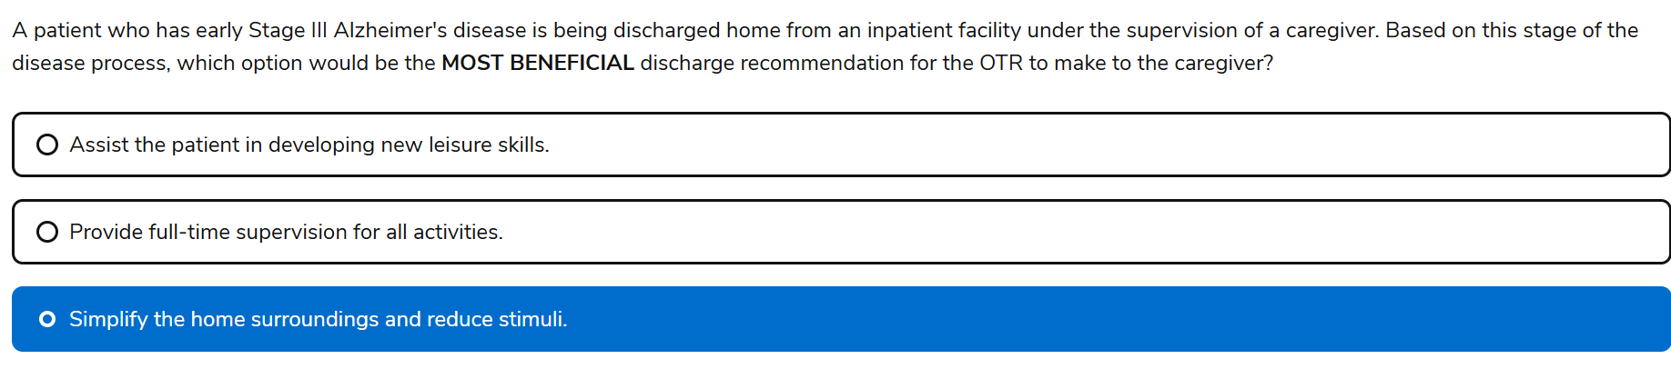

98. Task based 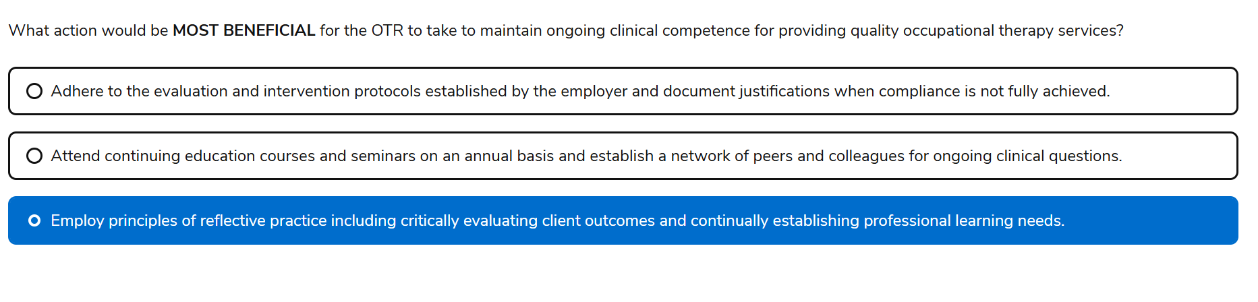

99. Knowledge

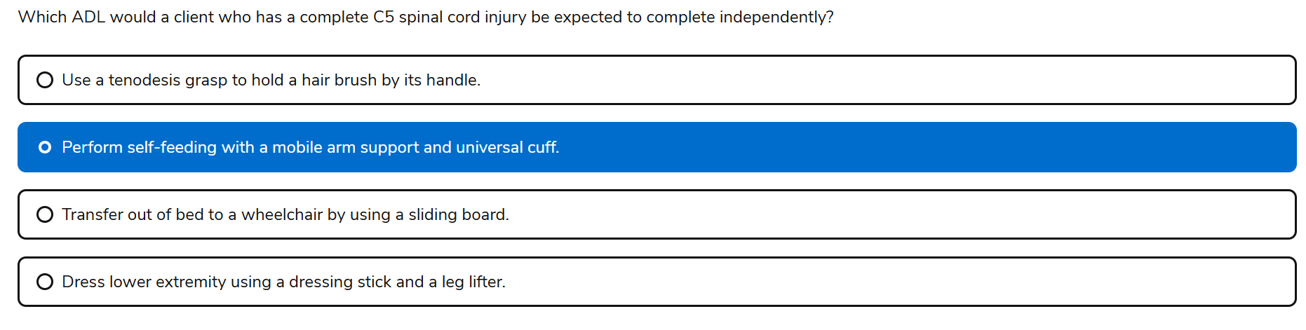

100. Knowledge

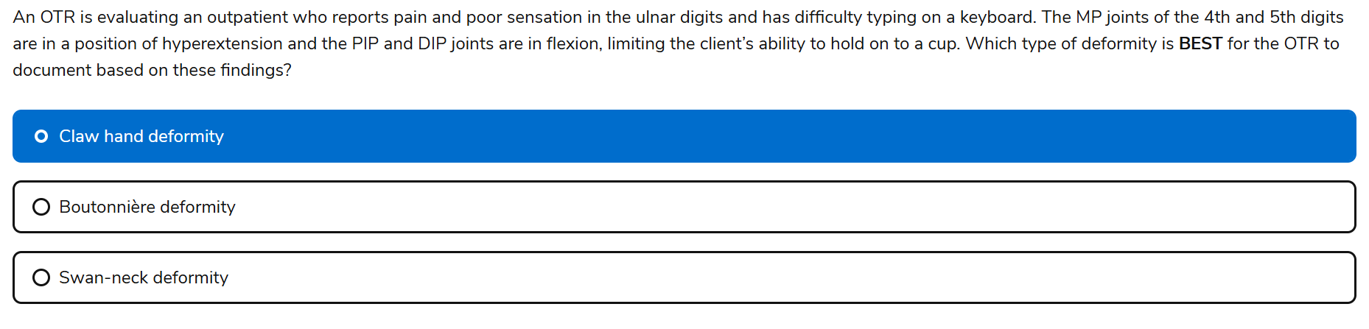

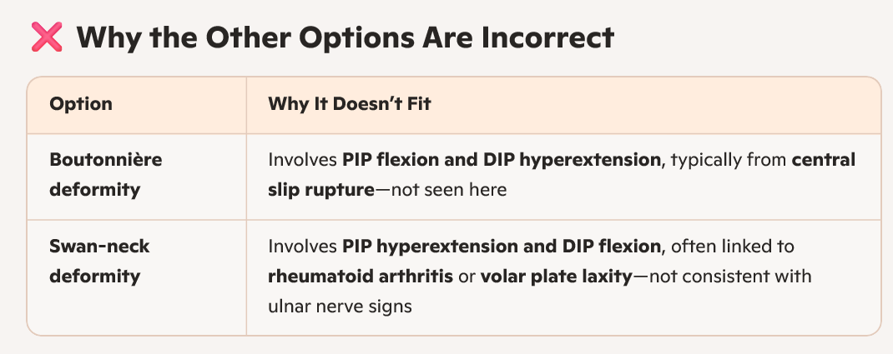

101. Knowledge

✅ "This is an expected response to activity; proceed with the session as planned."

🫀 Why This Is Correct (NBCOT-style rationale):

• Phase II cardiac rehab involves monitored, progressive aerobic exercise in an outpatient setting.

• A heart rate increase of 20 bpm during activity is within normal limits for a patient post-MI, especially if:

• The patient is asymptomatic (no chest pain, dizziness, or dyspnea).

• Vital signs are stable.

• The activity is submaximal and supervised.

102. Task based

103. Task based

Aerobic Exercise:

* **Definition:** Aerobic exercises are sustained activities that increase heart rate and breathing over a period of time.
* **Oxygen Requirement:** They require oxygen to produce energy for sustained muscle activity.
* **Examples:** Jogging, swimming, cycling, brisk walking.
* **Benefits:** Improves cardiovascular health, endurance, and can aid in weight management.

Anaerobic Exercise:

* **Definition:** Anaerobic exercises involve short bursts of intense activity where muscles work at a high intensity for a brief period.
* **Oxygen Requirement:** They do not require oxygen to produce energy and instead rely on stored energy sources within the muscles.
* **Examples:** Sprints, weightlifting, high-intensity interval training (HIIT).
* **Benefits:** Builds strength, power, and muscle mass.

**104-knowledge**

✅ **"Assist the patient to transfer from the chair back to bed and position in supine."**

🧠 NBCOT-Style Rationale:

This patient is **recovering from respiratory failure** and was **recently weaned from mechanical ventilation**. After transferring to a recliner, their vitals show:

* **Heart rate**: 122 bpm (tachycardia)
  + 60-100 bpm normal range
* **Blood pressure**: 160/100 mmHg (hypertension)
* **O₂ saturation**: 93% (borderline low)
* **Respiratory rate**: 21 bpm (slightly elevated)
  + 12-20 bpm is normal range

These changes suggest the patient is **not tolerating the upright position well**, and the safest next step is to:

* Return them to **bed in supine** to reduce cardiovascular and respiratory strain.
* Monitor for stabilization before continuing any ADL or mobility tasks.

105-knowledge

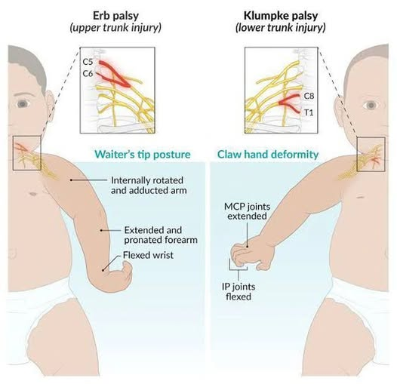

106-knowledge

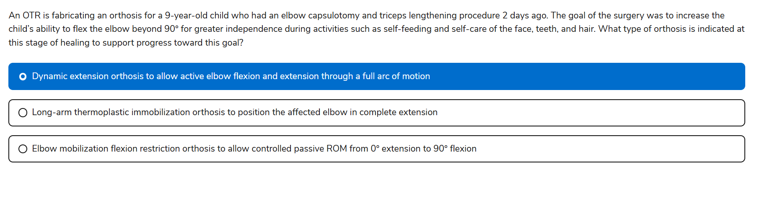

107-knowledge

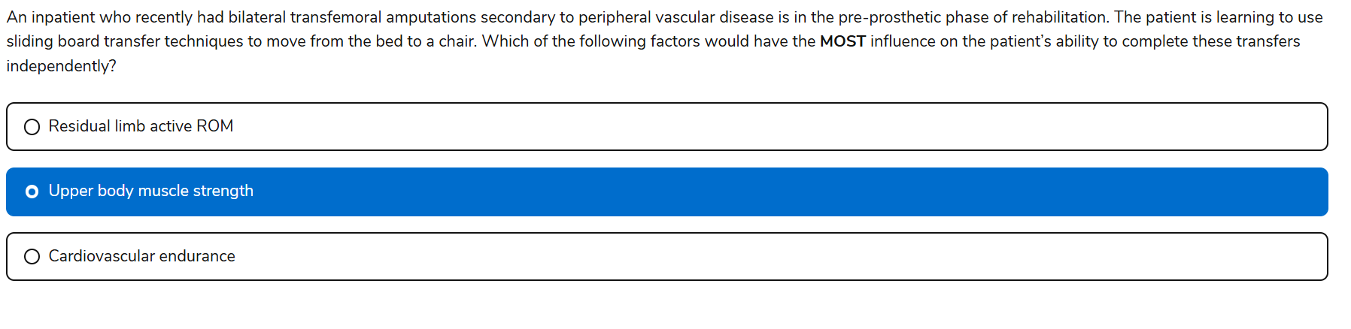

108-knowledge

Parkinson’s- resting tremors

retropulsion=involuntary backward movement or falling, particularly seen in conditions like Parkinson's disease. It's a type of postural instability where an individual's center of gravity shifts backward, making them susceptible to falls when trying to maintain balance.

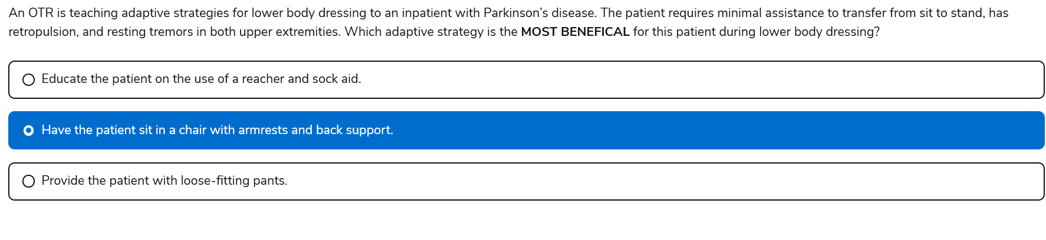

109-knowledge

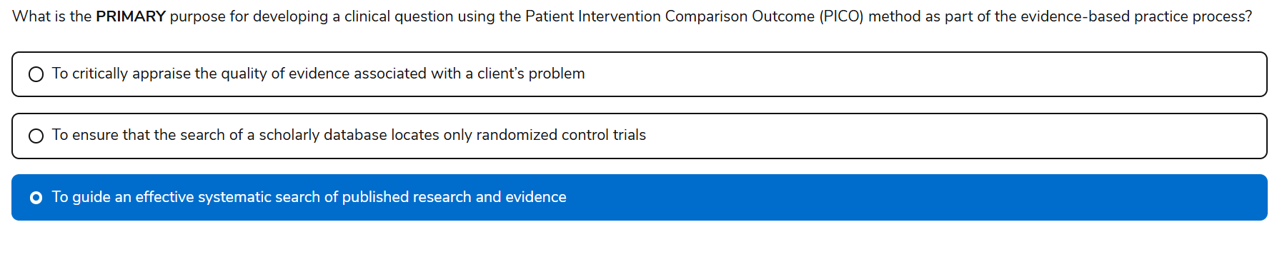

110-knowldege

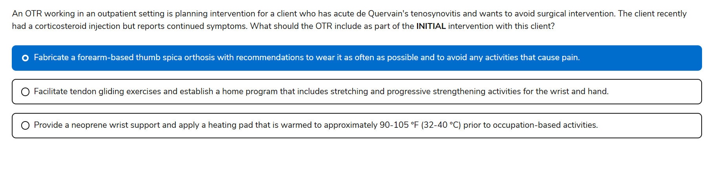

✅ Yes, **A is correct** — for a client with **acute de Quervain’s tenosynovitis** who continues to experience symptoms after a corticosteroid injection, the **initial OT intervention** should include:

🧠 Clinical Rationale for A:

* A **forearm-based thumb spica orthosis**:
  + Immobilizes the **first dorsal compartment** (APL and EPB tendons).
  + Reduces inflammation and pain by **limiting thumb and wrist motion**.
* Wearing it **as often as possible** and **avoiding painful activities** supports **tissue healing** during the acute phase.

❌ Why Not B or C?

* **B** (tendon gliding, stretching, strengthening): These are **appropriate in subacute or chronic phases**, not during acute inflammation.
* **C** (neoprene support + heat): May provide comfort, but **doesn’t offer sufficient immobilization** to reduce tendon irritation in the acute stage.

Absolutely, Keely—here’s a high-yield summary of the **most important assessments** you’ll want to know for the NBCOT exam, organized by domain and clinical relevance. This is designed to help you quickly recall what each tool measures, where it’s used, and why it matters.

## **🧠 NBCOT Assessment Summary**

### **🔹 ADLs & Functional Independence**

| **Assessment** | **Focus** | **Setting** | **Notes** |
| --- | --- | --- | --- |
| **FIM** (Functional Independence Measure) | Basic ADLs, mobility, cognition | Inpatient rehab (IRF-PAI) | 1–7 scale; used for Medicare reimbursement |
| **Barthel Index** | Basic ADLs | Rehab, hospitals | Quick snapshot of independence |
| **Katz Index** | Basic ADLs | SNFs, hospitals | Yes/no scoring; older adults |
| **Lawton IADL Scale** | IADLs | Community-dwelling older adults | Shopping, cooking, finances, etc. |

### **🔹 Cognition & Mental Status**

| **Assessment** | **Focus** | **Use** | **Notes** |
| --- | --- | --- | --- |
| **MoCA** | Mild cognitive impairment | Screening | More sensitive than MMSE |
| **SLUMS** | Cognitive status | Screening | Good for detecting early decline |
| **MMSE** | General cognition | SNFs, hospitals | Less sensitive; still widely used |
| **EFPT** (Executive Function Performance Test) | Executive function during tasks | Functional cognition | Includes cooking, phone use, meds |

### **🔹 Psychosocial & Emotional Health**

| **Assessment** | **Focus** | **Use** | **Notes** |
| --- | --- | --- | --- |
| **PHQ-9** | Depression | Screening | Used in outpatient and SNFs |
| **GDS** (Geriatric Depression Scale) | Depression in older adults | Screening | Short form is common |
| **Beck Depression Inventory** | Depression severity | Mental health settings | Self-report tool |

### **🔹 Motor & Sensory Function**

| **Assessment** | **Focus** | **Use** | **Notes** |
| --- | --- | --- | --- |
| **Nine-Hole Peg Test** | Fine motor coordination | Neuro, outpatient | Timed test of dexterity |
| **Box and Blocks Test** | Gross manual dexterity | Neuro, rehab | Measures speed and coordination |
| **Sensory Profile** | Sensory processing | Pediatrics, neuro | Parent or self-report formats |

### **🔹 Developmental & Pediatric Tools**

| **Assessment** | **Focus** | **Use** | **Notes** |
| --- | --- | --- | --- |
| **Peabody (PDMS-2)** | Motor development | Ages 0–5 | Gross and fine motor skills |
| **BOT-2** | Motor proficiency | Ages 4–21 | Coordination, strength, agility |
| **M-FUN** | Functional motor skills | Ages 2.6–7.11 | School-based OT relevance |
| **Denver II** | Developmental screening | Ages 0–6 | Personal-social, fine/gross motor, language |

### **🔹 Client-Centered & Occupational Performance**

| **Assessment** | **Focus** | **Use** | **Notes** |
| --- | --- | --- | --- |
| **COPM** | Client priorities & satisfaction | All ages | Interview-based; tracks progress over time |
| **Activity Card Sort** | Occupational engagement | Adults, older adults | Visual sorting of activities |
| **Role Checklist** | Role participation | Adults | Quick insight into valued roles |

### **🔹 Home Health & Medicare Documentation**

| **Tool** | **Purpose** | **Setting** | **Notes** |
| --- | --- | --- | --- |
| **OASIS** | Medicare documentation | Home health | Use conventions—not raw scores |
| **IRF-PAI** | Medicare payment tool | Inpatient rehab | Includes FIM scoring |
| **MDS** | Resident assessment | SNFs | Tracks ADLs, cognition, therapy minutes |
| **CARE Tool** | Data continuity across settings | Post-acute care | Standardized across SNFs, IRFs, HHAs |